

ST THOMAS MORE CATHOLIC HIGH SCHOOL

Year 7

Parent Handbook

2025-26

Contents | Page number
Mission Statement | 2
Christian Worship | 3
School Chaplaincy | 3
The First Day | 4
The Pastoral Support System | 4
Key Staff | 4
Code of Conduct – Standard of Uniform | 5 - 8
Code of Conduct - Timeliness | 8
Code of Conduct - Respect | 9
Code of Conduct – Independent Learning | 9
Code of Conduct – Value Learning | 9
Code of Conduct - Equipment | 10
Home School Partnership | 11
ParentMail | 11
Attendance & Punctuality | 12 – 13
Absence Procedures | 14
Medicines in School | 15
Contact with School | 16
Daily timetable | 17
Organisation of classes | 17
Library | 18
Extra-curricular activities | 18
School meals | 19
Free School Meals | 19
Bus Timetable | 20
Terms and Holidays 2025/26 | 21

We would like to welcome your child to St Thomas More and are providing this handbook to help you to support them with their transition. Knowing what to expect beforehand often helps the transition process so we have included some useful information that will hopefully answer the many questions you have.

Mission Statement
St Thomas More High School is a Catholic school, and as such we attempt to follow the example of Jesus Christ in our work, worship and relationships.

Our aims are:
- to be a prayerful community based on Christian values, notably Love, Justice, Peace, Truth and Tolerance, and to encourage individuals in their commitment to these ideals.

- to provide a secure, welcoming and ordered environment in which individuals learn to value and respect both themselves and others.

- to give individuals the opportunities to develop their full potential as human beings, and to encourage and challenge them to do so.

- to encourage everyone to strive to do their best and to strive for the highest standards in all areas of activity.

- to help children grow into confident, open, resourceful young people with a sense of responsibility and of service.

The School as a Christian Community
The school is a Christian Community with a distinctive Catholic ethos in which every student is encouraged to experience how God works in their lives and the world around them. We encourage our students to ask the big questions about life and get involved in the many different faith-based opportunities provided.
All students participate in collective worship every day in school as we believe that the foundation of any Christian Community must be prayer and worship. Each day in morning registration students are involved in leading prayer for the rest of their form class and once a week there is a year group assembly for Year 7 which will also include collective worship.
Mass is celebrated each week in school, with different year groups taking part on a weekly rota, and larger Whole School events take place at key liturgical times, including Advent & Christmas, Lent & Easter and on the Feast Day of St. Thomas More. Students are also given the opportunity to go on retreat and attend faith-based trips throughout their time at school.
We believe that we are called to be people of service, and so students are also encouraged to put their faith into action by participating in many of the charitable opportunities provided throughout the year. As Form Classes, students will fundraise and collect during Advent and Lent for different charities including CAFOD, St. Oswald’s Hospice, the Salvation Army food project and the Lourdes Pilgrimage. Students are also encouraged to fundraise or advocate for charities important to them and the Chaplaincy is here to help them to do that.
School Chaplaincy
It is important that as well as providing for our students’ academic and pastoral needs, we also provide for their spiritual needs. This vital mission is enabled through our School Chaplaincy and is supported by the work and ministry of our School Chaplain.
The School Chaplaincy is present for students to explore issues that are important to them and because of this its scope is wide ranging. Many students are engaged in Chaplaincy in different ways – getting involved in raising money for charity, taking part and planning for our religious services and liturgies, attending retreats or other faith-based trips, representing the school on a Diocesan level – and many quite simply use the Chaplaincy as a space to socialise and relax away from the bustle of school life. The School Chaplaincy intends to nurture the holistic growth of pupils encouraging them to live their lives their fullest and participate in activities outside of the classroom that are important to the growth and wellbeing of the individual.
The School Chaplain is present throughout all aspects of life in school, and is in school to walk alongside and journey with our students from the moment they step foot through our doors in Year 7 to when they leave at the end of their time at St. Thomas More. The Chaplain is here to listen when students are struggling, to talk when words are needed and to help when students feel stuck.
Our Chaplain, is always available should students have any concerns, need to talk about anything, or perhaps have any questions on their mind. The Chaplaincy office can be found upstairs in RE and students are encouraged to drop by any time.

The first day

School will re-open for Year 7 on Wednesday 3rd September at 8.45am. Year 7 students should enter via the service road gate and follow instructions from staff who will guide them to where they need to go.

Students should bring with them a school bag and their school equipment (see p10 for details). You will receive an email inviting you to register with ParentMail by the 2nd September, this will allow you to add funds to your child’s lunch account ready for them to use on the 3rd. Alternatively, students may bring a packed lunch. Students will not need their PE kit on the first day.

Pastoral Support System

In a school of 1600 students, it is important that each individual student feels safe, happy and valued. Our pastoral system aims to do just that. On entry to our school, each student is allocated a Head of Year and an Assistant Head of Year who will remain their Pastoral Leaders for 5 years, right through to the end of Year 11. Working under the co-ordination of a Head of Year and Assistant Head of Year, each form tutor has pastoral responsibility for a group of around 30 students. Through a planned pastoral programme, the form tutor addresses the social and emotional needs of students and supports their learning and development. Your child will be placed in one out of nine form classes and their form tutor will remain with them through their school career, building positive relationships, getting to know them and supporting them with school life.

Essential to valuing each individual is the system of rewards and praise, whereby students are awarded positives points for academic and social achievement. Contributions to the life of the form, year group and whole school, be they physical, mental or spiritual are also recognised through the praise system, ensuring that the achievement of each student can be acknowledged irrespective of academic ability.

Key Staff

Apart from the Form Tutor, the following staff will play a key role in different aspects of your child’s life at St Thomas More Catholic High School.
- Head of Year – Mr D Rayson
- Assistant Head of Year – Mrs J Green
- Mr P Flynn – Assistant Headteacher with responsibility for KS3
- Ms L Hagan – Senior Assistant Headteacher - Pastoral
- Mr S Anderson – Transition Coordinator

Your child may also receive support from the following staff.
- Mrs Thirkettle, Mrs Wenn and Mrs Kitcher – Receptionist & Attendance Clerk
- Tracey Leach – Attendance & Family Support Worker
- Mrs Swan – SENCO
- Mr Briggs & Miss Fairlamb – Associate SENCO
- Mrs Forsten, Mrs Barrett, Mrs Collins and Mr Wright – Learning Mentors
- Mrs Harbinson – School Counsellor
- Mrs Jones – Medical Conditions Coordinator
- TBC– School Chaplain

Code of Conduct – Behaviours for Learning

In school everyone should act with courtesy and consideration towards others at all times. Students will become familiar with STRIVE – we want your child to strive to be the best they can be.

We have high standards and expect students to meet our six STRIVE learning expectations every day:

S - Standard of Uniform
T - Timeliness
R - Respect
I - Independent Learning (Homework)
V - Value Learning (Classwork)
E - Equipment

Each of the six expectations are explained in more detail below.

STANDARD OF UNIFORM

As a school we have clear rules with regards to uniform. We want our students to look smart at all times, and therefore our students should be wearing the correct uniform at all times.

Main Uniform
White school shirt
Mid-grey traditional, tailored school trousers or school skirt
School tie (available only from school)
School blazer (available from Emblematic)
School jumper – optional (available only from school)
Plain black ankle socks, black opaque tights
Plain black traditional school shoes
(not trainers, boots or sportswear.)

PE Uniform
Polo shirt* – black, maroon and amber
Outdoor top* – black and maroon
Black, plain tracksuit bottoms, shorts or leggings (no branding)
Black football socks
Trainers (shoes not boots)
Football boots (studs)
*One of these is compulsory and both are recommended

Important points about Uniform and Appearance

- The jumper and tie are available only from school.
- The school skirt should be of a respectable length (no more than 2 inches above the knee).
- The blazer, skirt and PE uniform are available at Emblematic, Unit 26, North Tyne Industrial Estate, Benton, Newcastle Upon Tyne NE12 9SZ or online from www.emblematic.co.uk
- If students choose to wear an outer garment on top of their blazer in colder or wet weather it should be noted that denim, leather, hooded tops, leisurewear and sportswear e.g. tracksuit tops must not be worn. Outer wear should be a proper coat.
- Blazers should be worn at all times through the school day including coming to school and going home from school.
- The colour for trousers is mid-grey. Girl’s trousers, if worn rather than the school skirt, must be mid-grey (charcoal) rather than light grey and must be full length, traditional tailored trousers. Trousers that are ‘skinny-fit’, ‘jegging like’ (stretchy) material or that are tight along the leg and/or ankle, often with visible zips are not acceptable school uniform (please see the image below for examples). This misinterpretation is frequently due to shops advertising items under the “school uniform” section, even though they do not conform to St Thomas More’s uniform policy.

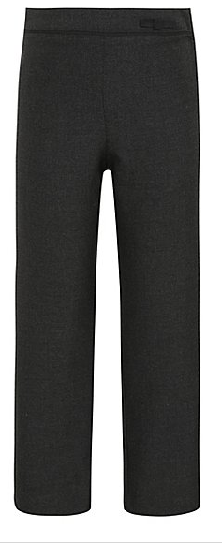



- Shoes should be plain black leather (or mock leather) traditional school shoes (not trainers, boots, sportswear, or canvas shoes). Again, please be aware that some shops advertise items under the “school uniform” section, even though they do not conform to St Thomas More’s uniform policy. Shoes that look like trainers are not acceptable. Further details can be found below.

Although not an exhaustive list, the examples below should provide clarity as to footwear that is unacceptable as a school shoe and so must not be worn.

- Shoes must be plain black with no coloured or contrasting trim, logos, flashes or branding.
- No trainers, pumps, plimsolls or trainer-type shoes (including skate shoes such as Vans).
- Trainers will only be allowed for PE or sporting events.
- Boots are not allowed, only shoes below the ankle.

- Girls’ shoes must be flat with no platform or heel.
- If you are in any doubt re the suitability of a pair of shoes – contact the school before purchasing for guidance.

Examples of unacceptable footwear:

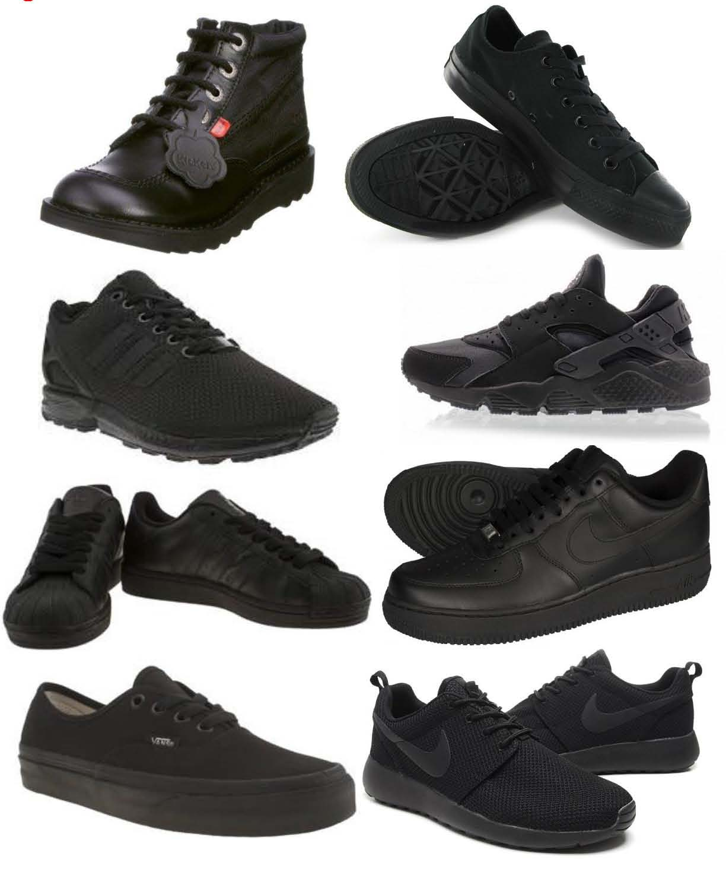




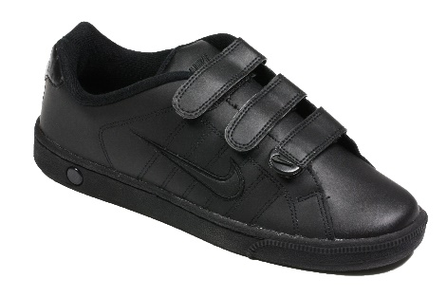

Hair
We expect students to avoid extremes of fashion in uniform and appearance, particularly with regard to hairstyle. For example, coloured hair and extremely short cut or shaven heads (including lines shaved in) are not acceptable (guidance: hair cut with clippers on a setting lower than a 2 is not acceptable); large or brightly coloured hair bands and other hair adornments should not be worn.

Make-up
Students must not wear make-up in Years 7 – 9 but students in Years 10 – 11 are allowed to wear discreet make-up. No jewellery is allowed, except for a watch and one pair of plain ear studs only (one in each ear lobe) and students should not have facial or tongue piercings. If your child arrives at school with any other kind of piercing including facial piercings of any kind then they will be expected to remove it. When a piercing is first done then it often needs to be kept in for a period of about 6 weeks. This will not be allowed in school.
False nails or nail varnish must not be worn by any student. Fake eye lashes are also prohibited in school.

The examples above are not an exhaustive list and the school may give clarity regarding other aspects of uniform and appearance as becomes necessary.

Students are responsible for their own personal property in school. Occasionally items do
go missing, this is often due to forgetfulness or carelessness. Problems will be kept to a
minimum if:
- clothing and other items are marked with the owner’s name
- valuable items or equipment are not brought to school
- students only bring to school amounts of money needed for the day

Unfortunately, we are not able to accept liability for items of personal property in school.

If a student experiences an unforeseeable incident and has to wear incorrect uniform, they must report to their Head of Year before 8.45am, who will endeavour to loan temporary appropriate uniform where spares are available. School expects any student without correct uniform to borrow it for the day.

Phones
Mobile phones are a prohibited item. If they are needed for travel purpose then they must be switched off before arriving on the school site and are not to be seen or switched on during the school day. If a mobile phone is seen on school site, then it will be confiscated. Further details about phones and other prohibited items (in line with DfE guidance) can be found in the school Network Acceptable Use and whole school Behaviour policy which are both available on the school website.

TIMELINESS
The school day starts at 8.45 and ends at 2.55. Students must arrive to school on time and be in their form class before the bell goes at 8.45. They must also arrive to all lessons on time throughout the school day.

RESPECT
At St Thomas More we take pride in the positive, respectful relationships between staff and students. We expect students to have respect for themselves, other students and all the adults that work in the school regardless of whether they are teaching staff or support staff. Students who wish to succeed do not answer back and trust that instructions from staff are intended to help and support them. It is important for students to learn self-discipline and self-regulation to be successful in school and life.
If any student shows a lack of respect to staff and answers them back, is insolent or defiant to them then a consequence will be issued and parents/carers will be informed. Thankfully, such instances are very rare and the number of students who show disrespect is very low.

INDEPENDENT LEARNING (HOMEWORK)
Homework will be set each day and could take up to an hour to complete. The homework set may involve various tasks such as reading, writing, learning, research, drawing and other creative work. Homework is compulsory for all pupils.

Students will be issued with homework through Classcharts. Parents are also asked to check Classcharts regularly to ensure that homework is being completed on time. Classcharts is a secure website where staff can upload homework and allocate it to specific pupils. During the first week in September all Year 7 pupils will receive a letter with an invitation for themselves and parents/carers to register. We strongly encourage parents and carers to register with Classcharts to be able to support their child with their homework. If you have any difficulties registering, please contact school.

VALUE LEARNING
Students will be treated politely and fairly by staff and we expect the same standard of behaviour from our students. For example: students should not chew in class; always sit where they are asked to sit; take off their coat when they arrive and follow the teacher’s instructions carefully.

Each teacher runs his/her classroom in a slightly different way and students should try to understand what each teacher expects of them. Making the classroom a pleasant place helps all of our students to learn and the teachers to teach.

EQUIPMENT

To enable your child to work effectively in school they must strive to bring the correct equipment every day which includes:
- School Bag
- Reusable water bottle
- Reading Book (Year 7, 8 & 9)
- Pencil case including;
  - 2 x black/blue pen
  - 1x pink pen (writing pen, not a felt-tip or highlighter)
  - 1x pencil
  - 1x ruler
  - 1x rubber
  - 1x scientific calculator (the Maths department will provide further guidance on specific models of scientific calculators).

Outside School
Students must show concern for our neighbours and the other passengers on buses. Remember that the school’s reputation depends on how they behave.

When Things Go Wrong
Certain kinds of behaviour are unacceptable in School and students will be expected to make up for what they have done wrong. This might mean extra homework or detention so that they can catch up on work, which has been missed. So that we make sure a problem is not developing, a record of such events will be made. More serious problems may lead to students being sent to their Assistant Head of Year, Head of Year, Assistant Headteacher or another member of Senior Staff. Whatever the problem, it will be up to them to work with staff to put it right.

Remind your child that if they need help for any reason, ASK – either their Form Tutor, Assistant Head of Year, Head of Year, or any member of staff they find it easy to talk to. Don’t let problems build up.

Home School Partnership

The development of a young person is shaped by the influence of both home and school life. The partnership between home and school is essential if our young people are to meet their potential. Our pastoral and academic systems are designed to supplement the guidance offered by caring parents and reinforce our common values as we seek to do our best for our young people.

There are some key areas that we seek the support from parents:
- Ensuring regular and punctual attendance to allow students to achieve their potential
- Ensuring that homework is completed on time and to a good standard
- Attendance to Parent’s Evenings to meet with Form tutors and teaching staff to share positive achievements and highlight any concerns.

ParentMail

ParentMail is a service paid for by schools to help communicate and collect payments from parents and carers. It is free for parents and carers to use.

We use ParentMail on a daily basis to contact parents and carers with school news, events and reminders. ParentMail also allows parents and carers to pay for school meals or school trips online.

We strongly encourage all parents and carers to register with ParentMail. The first step in the process is to provide school with your email address, then follow the instructions provided in the registration email*. Further information, help and FAQ’s are available by following the ParentMail link on the school website.

We also recommend parents download the free ParentMail App onto their smart phones. Doing this means you won’t need to search through busy inboxes for school messages or have to remember login details.

*Registration emails will be sent at the beginning of term, approximately the 2nd September 2025 *

Attendance & Punctuality

The link between attainment, behaviour and attendance is very clear, and it is the responsibility of both Parents/Carers and the school to ensure that our students attend every day in order to maximise their learning opportunities. We follow government targets and ask that all students and parents aim for a minimum of 96% attendance. Schools and Local Authorities strive to promote good attendance, reduce absence and ensure every student has access to full-time education. Irregular attendance undermines the educational process and leads to educational disadvantage.

Why is good attendance and punctuality important?

Good attendance helps students to make progress academically and socially, and feel part of our school community. Building positive relationships in school supports students in having good mental health and wellbeing. Attendance at school is important to build confidence and self-esteem, to develop awareness of other cultures, religions and ethnicities. Students develop life skills to support them in having the best possible start in life.

The table below shows how a student’s percentage attendance relates to the number of days and lessons missed. As you can see, 94% attendance may initially appear to be good however, this translates to a student missing 55 hours of lessons over the course of a school year which will have a negative impact upon their progress.
*2 sessions = 1 day (am & pm)
Attendance % during one academic year | Equivalent number of days absent | Equivalent number of sessions* absent | Equivalent number of lessons missed
98% | 4 days | 8 sessions | 20 lessons
96% | 8 days | 16 sessions | 40 lessons
94% | 11 days | 22 sessions | 55 lessons
92% | 15 days | 30 sessions | 75 lessons
90% | 19 days | 38 sessions | 95 lessons
85% | 28 days | 56 sessions | 140 lessons
80% | 38 days | 76 sessions | 190 lessons
75% | 48 days | 96 sessions | 240 lessons
70% | 57 days | 114 sessions | 285 lessons

It is very important that your child not only comes to school regularly, but also gets to school on time. Good time keeping breeds good habits and plays a significant role in preparing students for their life ahead. Pupils who are regularly late can expect to receive sanctions in the form of detentions. The table below gives an indication of how poor punctuality can impact a students learning.

If you were late to school every day by… | In a year you would lose… | Or you would miss approximately…
5 minutes | 3.5 days from school | 18 lessons
10 minutes | 7 days from school | 35 lessons
15 minutes | 10 days from school | 50 lessons
20 minutes | 14.5 days from school | 73 lessons
30 minutes | 22 days from school | 110 lessons

How can parents and carers encourage good attendance and punctuality?

- Establish a good routine in the mornings and evenings so your child is prepared for the school day ahead, and arrives on time.
- Encourage your child to have good sleep habits and support them by limiting screen time in the evenings.
- Take an interest in your child’s education; ask about school work and homework.
- Encourage your child to get involved with school activities.
- Praise and reward your child’s achievements at school.
- Discuss any problems that you think may have a bearing on your child’s attendance with the school. Inform their Head of Year at an early stage so the school can take measures to help your child.
- Attend, where possible, parent evenings and school events.
- Take truancy seriously. If your child is not attending school as you expect they may be putting themselves at risk – Who are they with? What are they doing?
- Encourage resilience and do not let your child take time off for minor ailments.
- Do your best to arrange routine medical, dental appointments etc. after school hours.
- Arrange family holidays outside of term time.
- Talk to your child about the importance of good attendance and punctuality. (For example if their attendance is 92% they would miss 75 hours of learning during the academic year.)
- Regularly check ParentMail messages, text messages and letters sent from school.
We are here to help you so do not hesitate to get in touch with the school if you have any specific concerns to do with attendance matters. Where the attendance of a student drops below a given level, the school will contact parents with the aim of improving the attendance of the child. Our Family Support Worker can offer advice and support to individual students and families when attendance problems arise. We are very grateful for your support in these matters.

Absence Procedures

Unexpected absence procedures:

If your child is ill or unable to attend school, Parents/Carers are encouraged to use Arbor (from September) to notify school by 8.45am on each day of the absence providing the name of their child, the reason for absence (please be specific regarding the nature of the illness rather than stating ‘unwell’) and when the student can be expected back in school.

Alternatively, Parents/Carers should contact the school by 8.45am on each day of absence, by calling the Attendance line on 0191 2588354 and give the reason for absence (please be specific regarding the nature of the illness rather than stating ‘unwell’) and an indication of when the student can be expected back in school.

Planned absence procedures:

Where possible, all routine medical and dental appointments should be taken out of school time. If your child has a medical appointment during the school day parents need to inform the school before the absence can be authorised, this can be done by Arbor (from September) or telephone (0191 2588354).

To assist us in ensuring medical or dental absences are authorised we request that parents/carers provide a copy of the appointment card or letter, the student can bring the letter to school and present it to the Attendance Clerks for our records to be updated. Depending upon the time of the appointment, students should attend school before and after the appointment time to minimise time spent out of school.

Please do not take family holidays during term time as these may be marked as an unauthorised absence.

You must complete a holiday authorisation form if you wish to take a term time holiday (available on the school website). Amendments to DfE Attendance Regulations, from September 2013, Headteachers may NOT grant any leave of absence during term time (including family holidays) unless there are EXCEPTIONAL circumstances.

Medicines in school

If a child has a long term or complex medical need (e.g. Asthma, Epilepsy, Diabetes, severe allergies etc…) parents must contact the Medical Conditions Coordinator (Mrs Jones) at school and complete an Individual Healthcare Plan (IHP). If you wish your child to carry medication or for the school to supervise the administration and store medication you must complete an Administration of Medication Form. Without this written consent, we are unable to supervise the administration of medication to a child, and the child cannot carry their own medication in school. The Administration of Medication form is available on the school website, or alternatively you can request an electronic copy of the form to complete and return online via email. Please contact Mrs Jones, the Medical Conditions Coordinator if you have any queries.

Medication prescribed by a medical practitioner can be administered to a child regularly. All medication must be presented in its original packaging, with instructions for dosage and administration.

The Medical Conditions Coordinator should be aware of all medicines taken in school. They ensure we have appropriate parental authorisation; medication is stored securely and the administration of medicines is recorded.

As part of planning for an educational visit out of school, staff will ensure that they are aware of any students who require medical support or medicine whilst on the trip.

Contact with school

- Early in the Autumn term we hold a parents’ evening where you can meet with your child’s Form Tutor to discuss how he/she has settled into St Thomas More Catholic High School. This may be an online or face to face event. You will be updated in September about the structure of this event.
- In the Spring Term you will receive Interim Report. This is a single page providing an overview of a student’s progress in each subject.
- There will be a Parents’ Evening in the spring term when you will have the opportunity to meet each subject teacher and discuss in more detail your child’s progress.
- Finally, in July you will receive a Final Report, which will also include a comment from your child’s Form Tutor and Head of Year.

In between times, if you have any concerns regarding your child at school we encourage parents to contact the Assistant Head of Year or the Head of Year by telephone (2588340) or in person (appointments must be made in advance). Please keep in mind that all Heads of Year are teaching members of staff and will not always be immediately available.

When requested by school please complete any registration or information forms as this helps us ensure your child’s wellbeing in school. This asks for medical details, names, addresses and telephone numbers of those who may be contacted in an emergency. We require at least 2 contacts. We also request that you complete a consent form for school activities and school data.

Daily timetable

The school day starts at 8.45am each morning and students are expected to be in form by 8.45am.

The school day is organised as follows.

 | Each day
Registration | 8.45am – 9.00am
Lesson 1 | 9.00am – 10.00am
Break | 10.00am – 10.20am
Lesson 2 | 10.20am – 11.20am
Lesson 3 | 11.20am – 12.20pm
Lunch | 12.20pm – 1.05pm
Lesson 4 | 1.05pm – 2.05pm
Lesson 5 | 2.05pm – 2.55pm

Organisation of classes

There will be 9 tutor groups of mixed ability known as;

7T, 7H, 7O, 7M, 7C, 7A, 7S, 7R, 7E

Students will be taught in mixed ability groups for most subjects. Pupils in Maths will be set into bands based upon ability.

Year 7 is regarded as a diagnostic year and the progress of pupils is carefully monitored so that adjustments can be made when necessary. Children with identified learning difficulties will be catered for in small groups in Maths, English and Science.

In Key Stage 3 all students will study;

English | Maths | Science
Religious Education | French | History
Geography | Design technology | Food technology
Art | Textiles | Music
Physical education | Personal, social, citizenship and health education | Information technology, Computing & Business

Library

The school library is open to students before school from 8.15am and during break and lunchtime and after school until 4pm (except Friday when the library closes at 3.05pm). Help is available at these times with homework, project work and research.

Extra-curricular activities in PE

The PE department organises extra sports clubs before and after school. Morning clubs start at 8:00am until 8:45am. Students can attend the club even if they are unable to get in for 8:00am. After school clubs start at 3:05pm until approximately 4:15pm. Every student is welcome to attend clubs even if they do not play for the school team. Students are required to wear the official St Thomas More Catholic High School PE kit for all extra curricular activities and fixtures unless informed otherwise. Students are expected to arrange appropriate travel arrangements home from school.

Fixtures

Students invited to attend fixtures at home or away will always receive an invite letter with the relevant fixture information and a parent/guardian consent slip. Fixtures are usually concluded by 6:00pm at the latest but may run over depending on the fixture type and location. Please note that fixtures and clubs run dependant upon staff availability.
Examples of winter activities include:
- Football
- Hockey
- Rugby
- Basketball
- Netball
- Dance
- Table Tennis
- Badminton

Examples of summer activities include:
- Cricket
- Rounders
- Tennis
- Athletics
- Futsal

Examples of other extra-curricular clubs include:
- Code club
- Art club
- Journalism club
- Creative writing club
- Journalism club
- Reading club
- Table top games club
- Science, technology and engineering club

- Choir
- book groups
- Harry Potter club
- Electronics club
- Culture club
- Craft club
- T15 Club

SCHOOL MEALS
School has a purpose built, modern food court for the students. The catering team are working hard to provide healthy nutritious balanced meals, but at the same time accommodating students’ meal preferences. The café is open from 8.00am serving breakfast snacks and sandwiches.

At lunchtime there is a variety of options offering traditional meals, curry pot, pasta dishes and meat free choices. Students can also choose from a wide selection of sandwiches, jacket potatoes and a salad bar. Homemade cakes, biscuits and cold drinks can also be purchased

In addition to the regular menu tariff there are daily specials including £3.00* meal deals. Further details of meal options and prices can be found on the school website.

*Estimated meal tariff for September 2025.

PAYMENT OF SCHOOL MEALS
The school has a cashless system in place for the payment of school meals, this is to try to ensure that parents/carers can put money into their child’s account via Parentmail. Parents/carers can add a daily spending limit to their child’s account should they wish. Please contact the main office if you would like to do this. Students in receipt of free school meals will have their accounts automatically credited with £3.00* each morning. We use a biometric system which allows pupils to pay for their food using their thumb print, or alternatively a PIN. You will be required to complete a form stating the preferred method of payment.

*Estimated meal tariff for September 2025.

School will email all parents instructions on how to top up their child’s accounts via ParentMail at the start of the Autumn 2025 term. Please ensure that school has your correct email address.

FREE SCHOOL MEALS

If you think you may be entitled to free school meals for your child, please contact North Tyneside Council. Applications can be made on-line or by calling (0191) 643 2288.

Parents may wish to note that students in receipt of a free school meal are able to choose their meal daily from the same lunch menu as all other students do. Furthermore, as we use a cashless system for school meals there is no way to distinguish between those students in receipt of a free meal and those not. The free school meal funding is added to the students account just before lunchtime to allow them to purchase a meal. If a student wishes to purchase breakfast or a snack at break time additional funds will need to be added to the account, either via Parentmail or by using cash in the ‘top-up’ machine in the Dining Hall.
In addition to the daily free nutritious meal for the student, the school also receives significant additional funding from central government for every child who is signed up for a free school meal. We would therefore encourage all parents who believe their child may be eligible for a free school meal to apply – even if you think this may be for only a short period of time, or if you think your child may choose not to take the free meal each day.

SCHOOL BUSES

Some pupils may be eligble for free travel on the school and normal service buses. If you think that you may be eligible for a free bus pass you can check the criteria and apply online via the North Tyneside Council website on the following link

https://my.northtyneside.gov.uk/category/133/school-transport

ST THOMAS MORE CATHOLIC HIGH SCHOOL
SCHOLARS SERVICES TIMETABLES SEPTEMBER 2025 - 26

The bus company has not yet released the timetable for 2025 - 26. Once it is available, we will add it to the school website, below the Key Information tab on the main homepage.

SCHOOL TERM DATES 2025 – 2026

