Quick start guide
Getting started with Parental Access

What is Class Charts for Parents?

You will now be able to use Class Charts to keep track of your child’s homework tasks – what has been set, the date it is due, any resources the teacher has attached to help with completion and whether or not the homework was submitted on time.

Class Charts for parents can be accessed via our website, or by our iOS and Android apps.

You can access the parent website and links to the parent apps at:
https://www.classcharts.com/parent/login

Parent Code
You should have received a Parent code
from your school, which will look similar to the example code shown on the right.

This code is used to set up your parent account, which is covered on the next page.

Creating a Class Charts Parent account
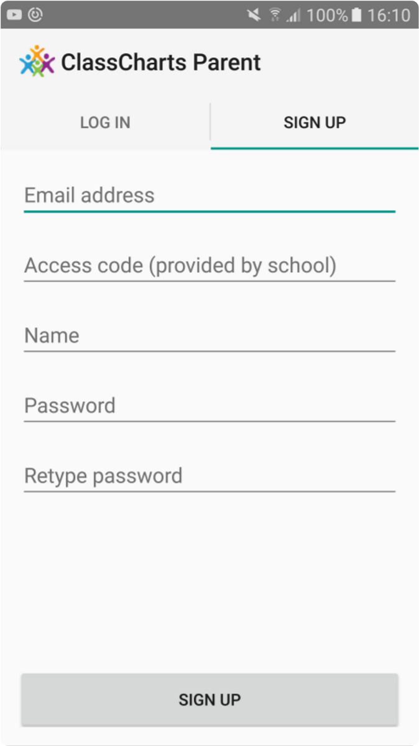
Creating an account via the app

If you click the Sign up tab within the app you will be presented with an account creation form.

Simply fill in the form and enter your parent code in the Access code field. Clicking Sign up will log you into the account.

Please note: Your Access Code is not the same as your password, the access code is only need for the initial sign up.

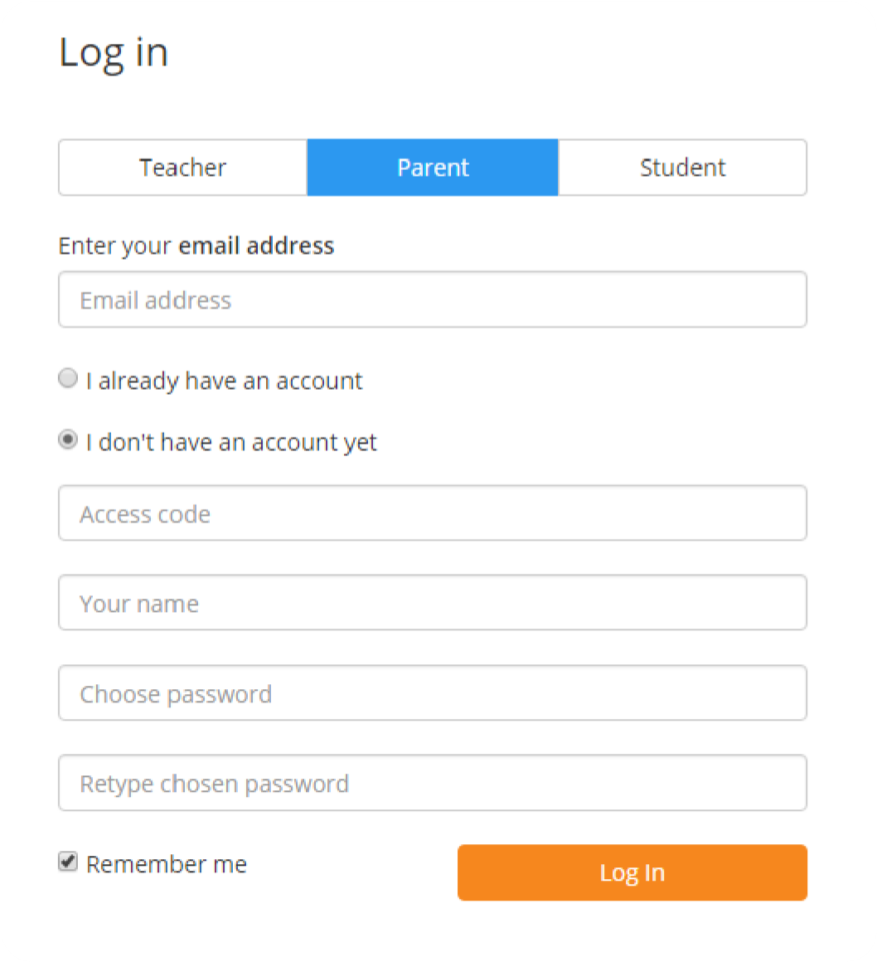
Creating an account via the website

To create an account on the website, select the I don’t have an account yet option.

This will bring up additional form options. Simply fill in the form and enter your parent code in the “Access code” field.

Please note: Your Access Code is not the same as your password. The access code is only needed for the initial sign up.

Homework
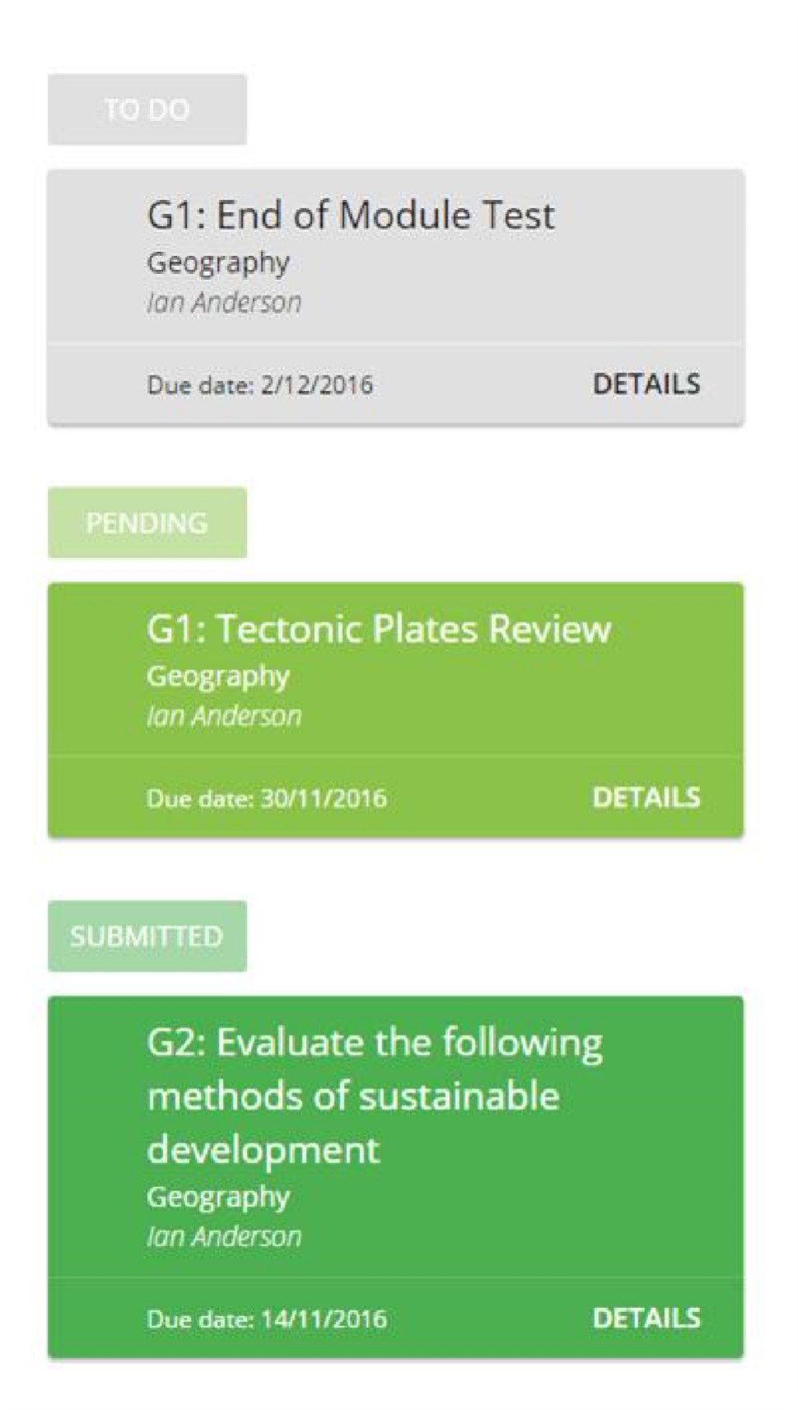
You will see a Homework option in the menu. Clicking on this option will display a list of the homework tasks which your child has been assigned to.

Homework tasks are displayed within 3 different categories: to do, pending, and submitted.

To do: These are the tasks that your child need to complete.

Pending: These task have been ticked as submitted by the student, but have yet to be confirmed by their teacher.

Submitted: These tasks have been confirmed as completed by the teacher who assigned the homework.

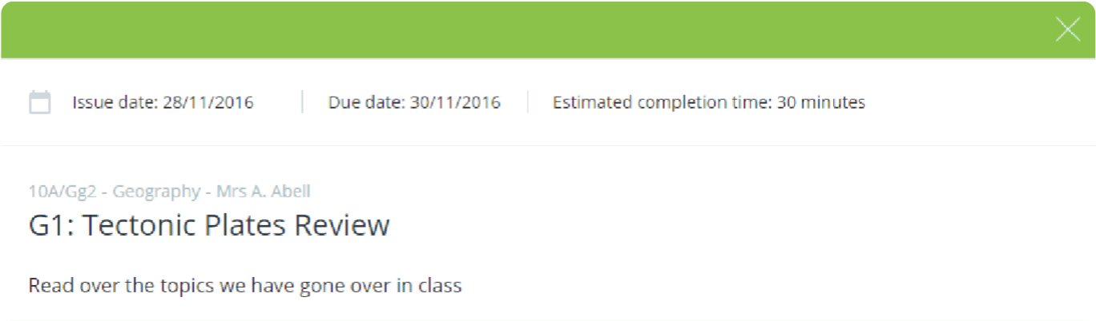
To view more
information, click on
Details

to bring up a
description of the
homework and any
other information
provided by the
teacher

Accessing Class Charts for Parents
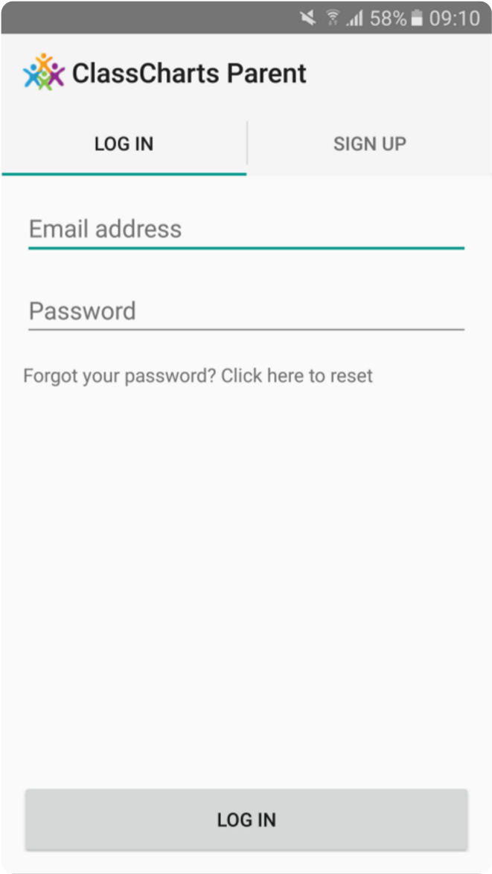
Logging in to the Class Charts Parent app

When you tap the parent app icon on your device, you will be presented with the Class Charts Login screen.

Simply enter the email address and password you used when creating your Class Charts account and you will be able to log back in.

If you cannot remember your password you can click on the forgot password link to receive a password reset email.
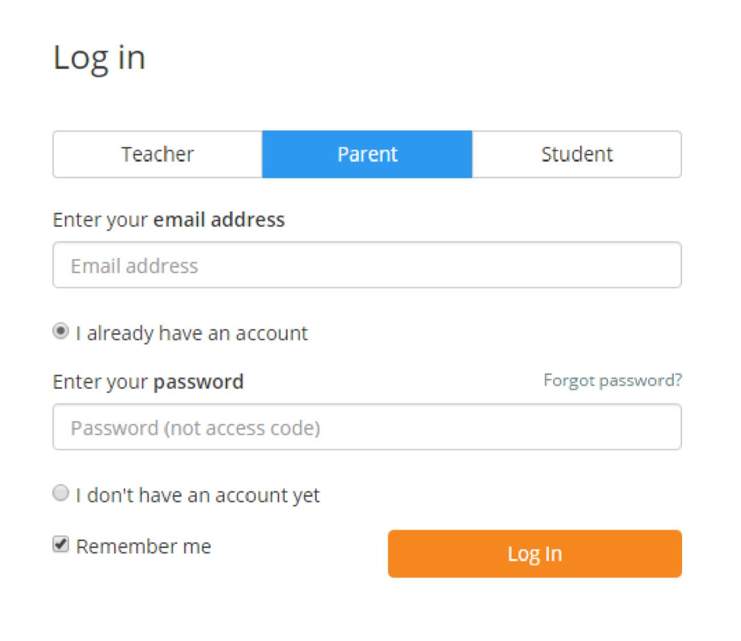
Logging in to the Class
Charts Website

To log back into your Class Charts account, first ensure that you have selected the parent option.

Next, select the I already have an account option and enter your login details.

If you cannot remember your password you can click on forgot password to reset it.

Settings
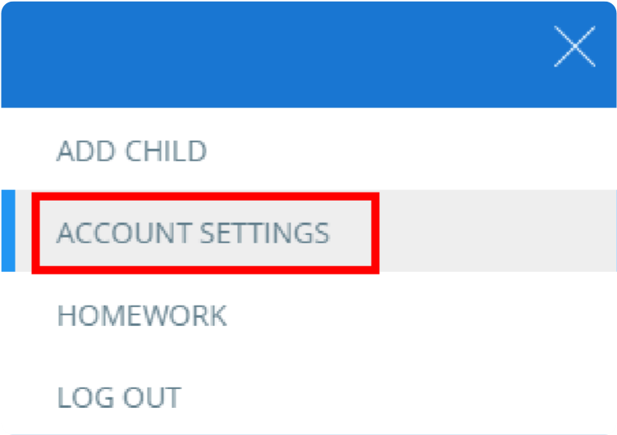
To access the settings menu for your parent account, select Account Settings from the 3 lines menu in the top right corner of the website.

If using one of the parent apps, you can access the settings menu by clicking on the settings cog shown on the right.
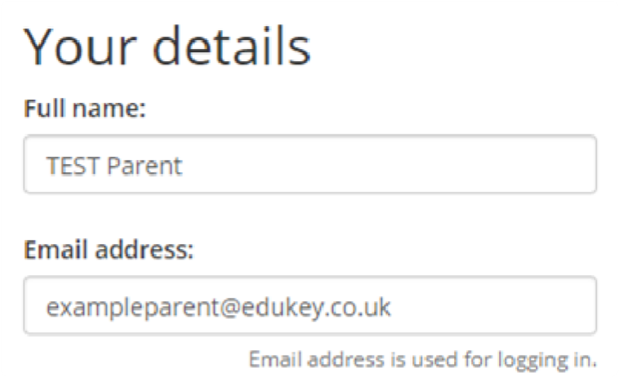
Within the settings menu, you will be given the option to change your name, along with the email address and password that you use for your account.

You can also change the displayed language, by selecting a different option from the Language drop down menu.

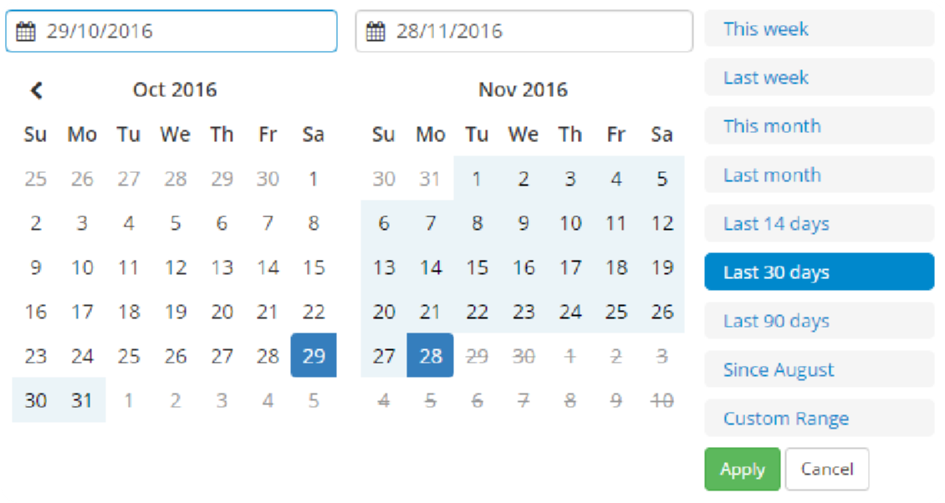
To change the timeframe that your account displays information in, click on the date range in the top right hand corner of the
website.

If using the apps, click on the calendar icon. You will be able to apply present date ranges or a custom range of your preference.

To set a custom date range, simply click on your start date and then your end date and click apply

