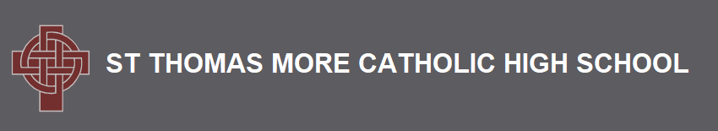

Mission Statement

St Thomas More Catholic High School is a Catholic school and as such we attempt to follow the example of Jesus Christ in our work, worship and relationships.

Our Aims Are:

- to be a prayerful community based on Christian values,
notably Love, Justice, Peace, Truth and Tolerance, and to encourage individuals in their commitment to these ideals.

- to provide a secure, welcoming and ordered environment in which individuals learn to value and respect both themselves and others.

- to give individuals the opportunities to develop their full potential as human beings, and to encourage and challenge them to do so.

- to encourage everyone to strive to do their best and to strive for the highest standards in all areas of activity.

- to help children grow into confident, open, resourceful young people with a sense of responsibility and of service.

