BTEC DIT – 9 Mark Question Tips - Assess
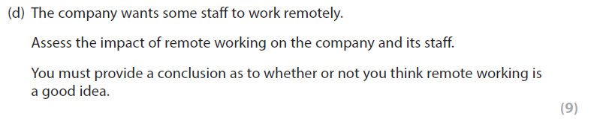
9 Mark Question – Assessing the impact
QUESTION:
Assess the impact of remote working on the company and its staff (9)
TIP:
- There is a chance that they may ask you to assess two options/stakeholders e.g. company and its staff
- For nine marks you must assess whether remote working is a good idea for the company and its staff
- Candidate will be able to identify suitable advantages/positives and disadvantages/negatives of remote working (recall)
- Candidate will consider different factors with development/reasoning, to fully assess the impact (reasoning)
- The answer must include realistic impacts which are related to the context of the company i.e. designing and selling gadgets (relate)
- It is asking you to assess so you will need balance in the answer. You will achieve this by suggesting advantage/positives s and disadvantages/negatives of the price increase
- The answer needs an overall conclusion at the end i.e. to summarise and give an overall judgement
- You can only get maximum marks if the written communication is a high standard (spelling, grammar and punctuation - SPaG)
- Remember the 3 x Rs (recall, reasoning, relate)
POSSIBLE FACTOS - RECALL
Positives – Organisations  - Lower overheads  - Better productivity  - No need to employ local staff  - Need fewer management staff  Positives – Staff  - Saving on travelling costs  - Saving on travel time  - shortens the working day  - Saving on clothing costs  - Flexible working  - Stress free working environment/ better job satisfaction  - Take breaks when it suits | Negatives – Organisations  - Costly to set up  - May have security issues  - Staff may leave  - Difficult to manage staff  Negatives – Staff  - Higher household bills  - Lack of routine  - Lack of self-confidence  - No work social life  - Distractions  - May have an issue with work/life balance
9 MARK EXAMPLE ANSWER
“It would be beneficial for the gadget company to use remote workers as it means they will have less overheads, e.g. less rent for office space. This will give them fewer outgoing costs resulting in more profit. It will also be good for them as the staff will be more productive as staff will be away from a stressful environment, this means they can produce more gadget designs
On the other hand, it will be costly for the business to set-up. Staff will need specialist equipment such as a new laptop. This will give the business higher costs. In addition, it will be difficult for managers to communicate and manage their staff. This will lead to miscommunication and lower productivity

Staff will benefit from remote working as they will have no/little commuting time to work, this means they will have more time to work on design gadget projects. Also, this will promote more flexible working where staff can work around their home life e.g. childcare which will reduce stress and make them happy.
However, staff will have more household bills e.g. broadband charges for super-fast broadband required to access the online company system. Also, staff can be easily distracted by the TV or social media, this will reduce productivity and likely to meet project targets.

To conclude, I think remote working is useful to both the company and staff as it gives flexibility and can help reach out to a greater pool of skilled workforce. It is also useful to have the option of both when necessary.

