OCR GCSE Business 9-1

Revision Guide & Intervention Pack

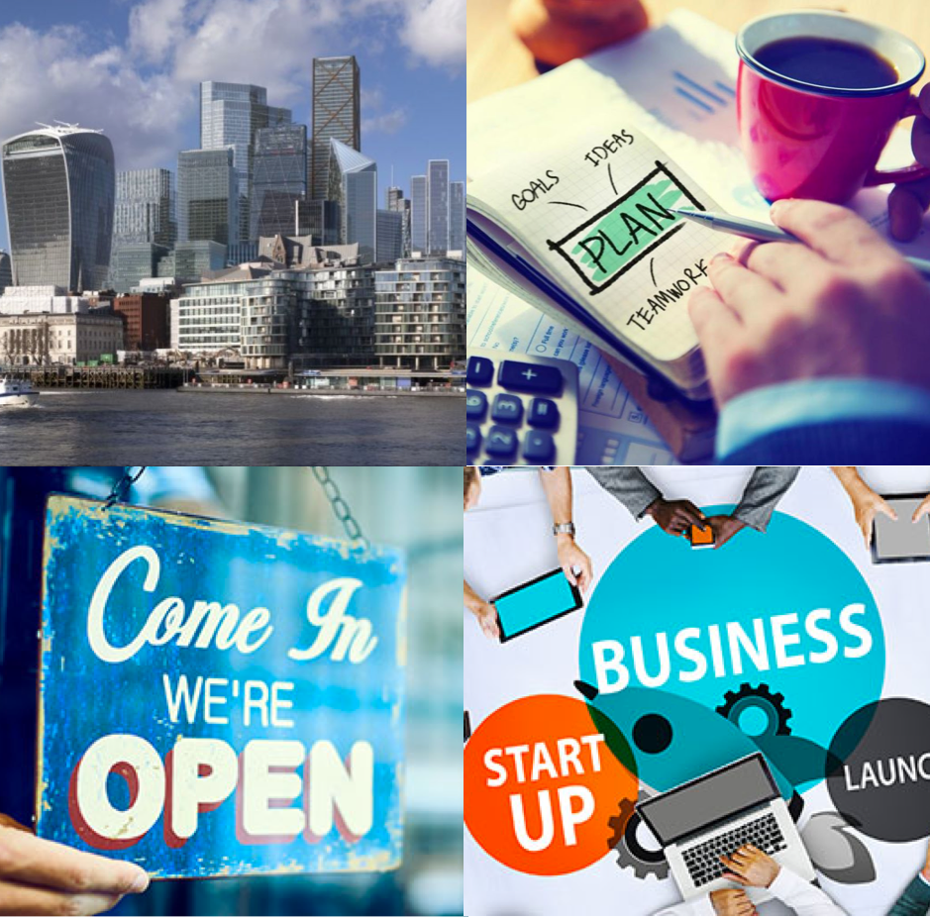

Paper 1: Business Activity, Marketing and People

Paper 2: Operations, Finance and influences on business

Name:___________________________________________
Contents
Paper 1 7
Unit 1 Business Activity 7
1.1 The Role of Business Enterprise and Entrepreneurship 7
1.2 Business Planning 10
1.3 Business Ownership 12
1.4 Business Aims and Objectives 18
1.5 Stakeholders in Business 20
1.6 Business Growth 22
Unit 2 Marketing 23
2.1 The Role of Marketing 23
2.2 Market Research 25
2.3 Market Segmentation 28
2.4 The Marketing Mix 31
2.4.1 Price 32
2.4.2 Product 37
2.4.3 Place 42
2.4.4 Promotion 48
Unit 3 People 51
3.1 The Role of Human Resources 51
3.2 Organisational Structures and Different Ways of Working 53
3.2.1 Organisational Structures and Charts 53
3.2.2. Ways of Working: part time and pull time working 56
3.3 Communication in business 62
3.4 Recruitment and Selection 68
3.5 Motivation and Retention 77
3.6 Training and Development 84
3.7 Employment Law 90
Paper 2 97
Unit 4 Operations 97
4.1 Production Processes 97
What are production methods? 97
Job Production 97
Batch Production 98
Flow Production 99
Automation and The Influence of Technology on Production 101
4.3 Quality of Goods and Services 104
The importance of Quality 104
Quality Assurance 106
Quality Control 107
4.3 The sales process and customer service 109
E-Commerce 109
Face to Face 115
Telesales 115
Providing good customer service 117
4.4 Consumer Law 119
Customer Rights 119
Impact of customer rights on businesses 119
4.5 Business Location 121
Factors affecting choice of location 121
4.6 Working with suppliers 122
Procurement and the Role of Procurement 122
Factors affecting the choice of supplies 122
Choosing Suppliers 123
The Length of the supply chain 124
Unit 5 Finance 126
5.1 The role of the finance function 126
Purpose of the finance function 126
Influence of the finance function on business activity 127
5.2 Sources of Finance 128
Why do businesses need finance? 128
The nine sources of finance 129
131
5.3 Revenue, Cost, Profit and Loss 132
Revenue 132
Costs 132
Profit and Loss 133
Profitability Ratios 135
5.4 Break-Even 138
Concept 138
Calculation 138
Usefulness of Break-Even Analysis 139
5.5 Cash and Cash Flow 141
Importance and Explanation 141
Cash vs. Profit 142
Cash flow forecasting 142
Usefulness and Limitations of Cash Flow Forecasting 145
Unit 6 Influences on Business 147
6.1 Ethical and Environmental considerations 147
Ethical considerations 147
How can a business act ethically? 147
Environmental considerations 150
6.2 The Economic Climate 155
Income and Employment Levels 155
Impact on Businesses 156
Responding to changes 158
6.3 Globalisation 160
What is Globalisation? 160
What has caused globalisation? 160
Impact of Globalisation 161
Appendix A: Long Mark Questions, structures and Mark Schemes 170

PAPER ONE

Paper 1

Unit 1 Business Activity

The Role of Business Enterprise and Entrepreneurship

Key Q): What is meant by Business?
A business refers to a person’s regular occupation or trade or a commercial activity.

Key Q): Why do businesses exist?
Businesses exist to satisfy the needs of customers by producing a good or providing a service of some kind.

Key Q): What does enterprise mean?
In Business, Enterprise means to spot an opportunity.

Key Q): What is an Entrepreneur?
An Entrepreneur is a person who uses enterprise to create and follow some form of business activity.

Key Q): What are the common characteristics of Entrepreneurial Traits?
- Leadership
- Organisation
- Resilience
- Initiative
- Communication
- Hard working
- Determination

Risks and Rewards of Business Activity
Risks | Rewards
Financial – Most business ideas need financial backing and if the idea doesn’t work out, money can be lost. | Financial – High risk ideas can turn out to make the most money, giving the risk taker high monetary rewards.
Health – Running a business can be stressful and time consuming, which can harm a person’s health. | Independence – There can be a great reward of working for yourself and not following other’s orders.
Strained Relationships – The time needed to run a business can take people away from their family and friends. | Self-satisfaction – It is often very satisfying for entrepreneurs to see their idea come to life and be successful.

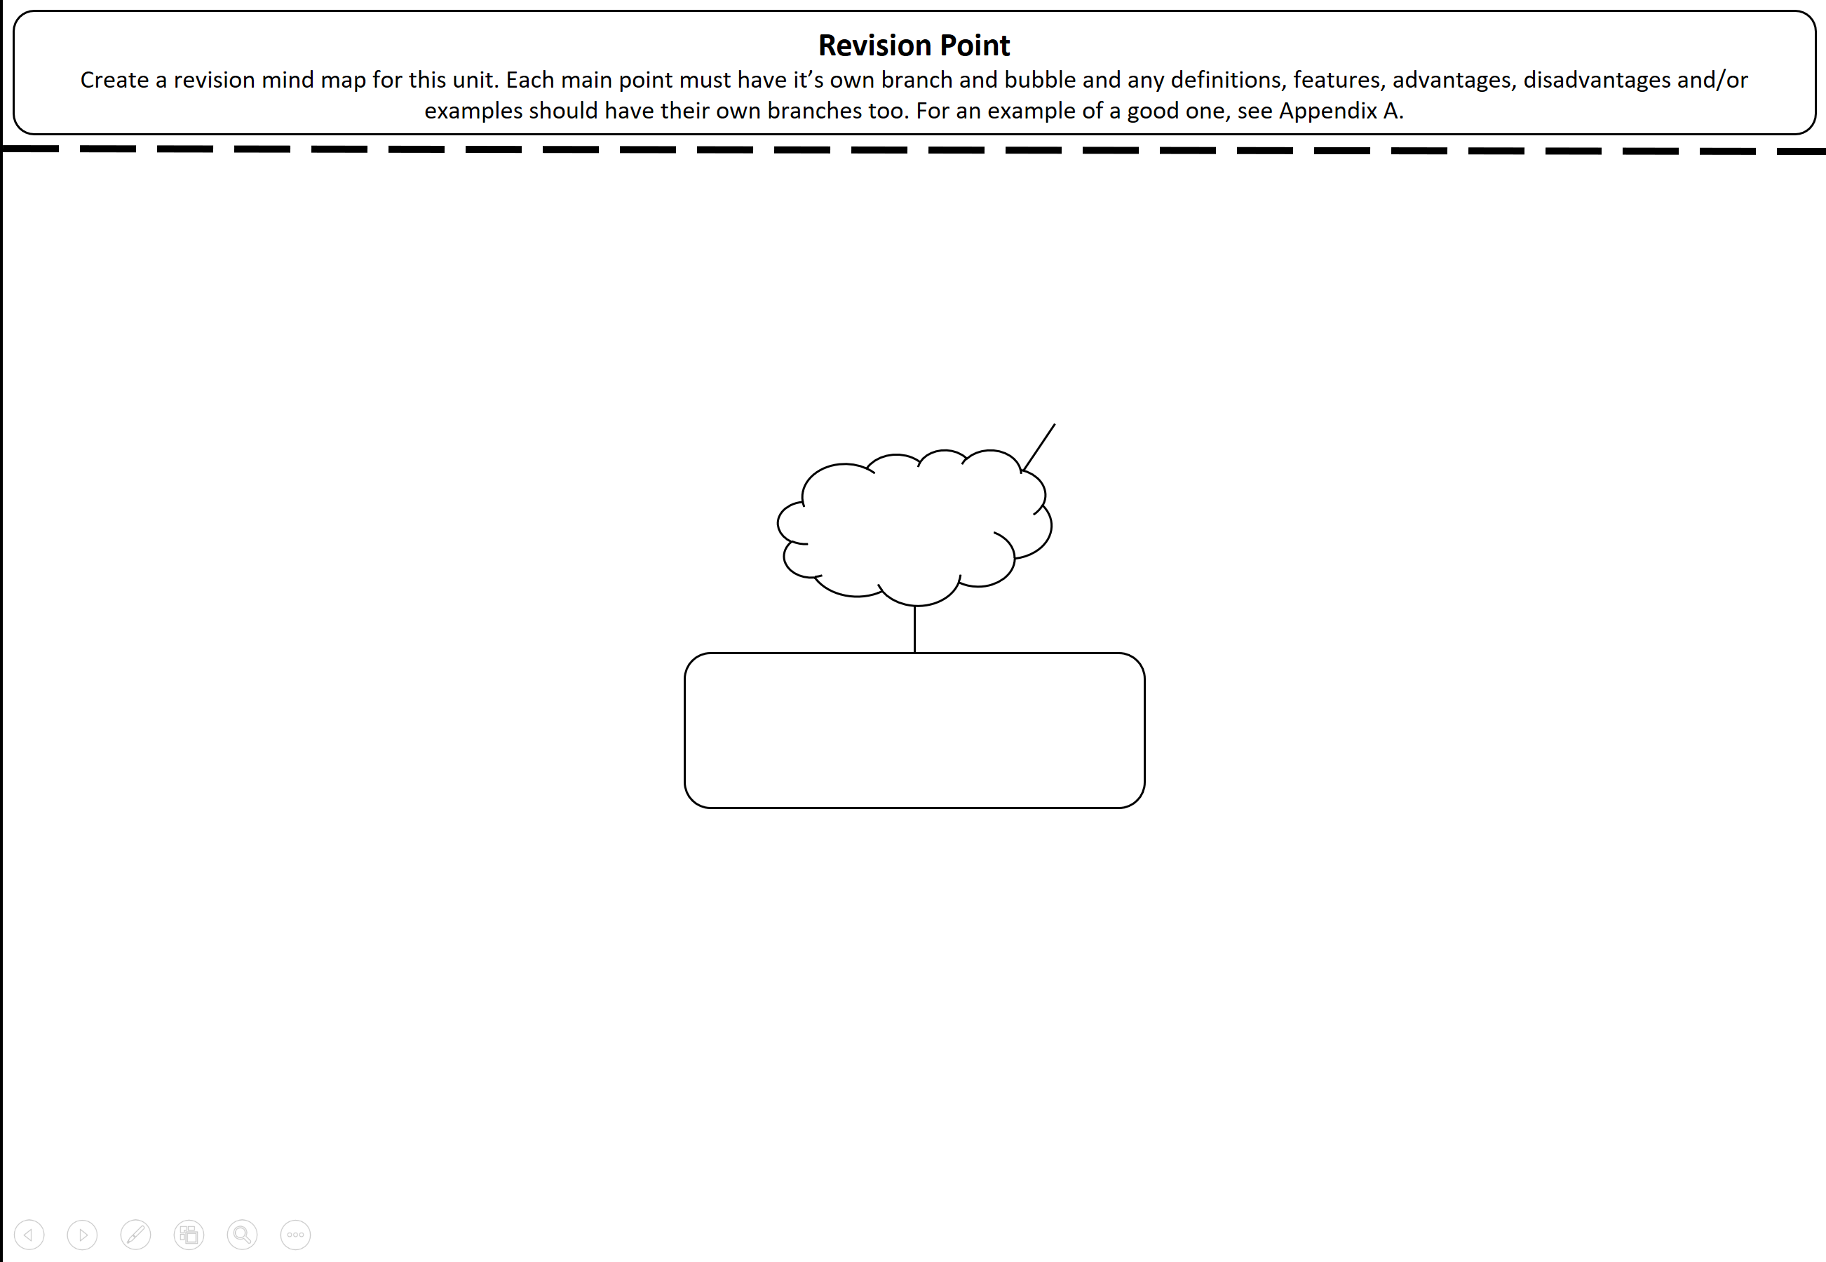

Business Planning

Key Q): What is a Business Plan?
A Business Plan details how a business aims to achieve its aims and objectives, usually written before the business starts or when there’s a major change

Key Q): Why do you need a Business Plan?

- To be clear on your aims and objectives
This helps you plan your activities to go on to achieve these aims.
- Reducing Risk
Having a business plan helps you spot and plan to reduce risk.
- Identifying Markets
The plan will help to spot all markets that can be sold to.
- Helping with Finance
A business plan helps to plan out where any money should be spent.
- Identifying the resources a business needs.
The plan will identify any materials, people or money a business needs to start.

Key Q) What is usually in a Business Plan?

- The business idea
A brief outline of the idea and the business purpose.
- Aims and Objectives of the business
A summary out what the business is setting out to achieve.
- The people running the business
A quick outline of all the people who own the business.
- Market Research
Research into the market and whether there’s a need for the business.
- Finance
A report on how much money is being invested and how much can be made.
- The Target Market
An outline of the people or places a business hopes to sell it’s products to/in.
- Competitors
A report of who the competition is and how a business can compete with them or beat them.

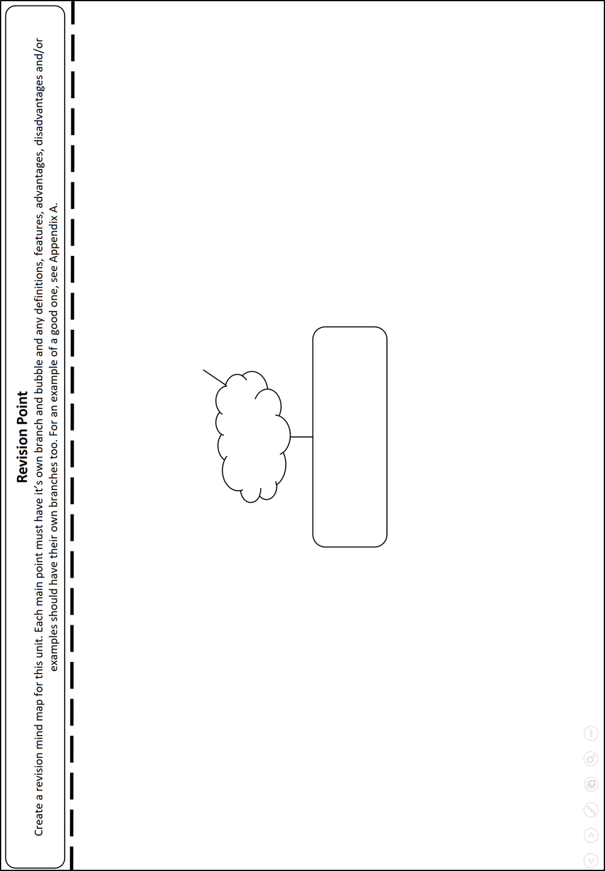

Business Ownership

Key Q): What is limited and unlimited liability?

Unlimited liability is where responsibility for all the debts of the business rests with the owner(s) of the business.

Limited Liability is where the responsibility for the debts of the business are limited to the amount of money a shareholder invests. So if they invest £100,000, that’s all they are liable to pay.

Key Q): What are the main types of Business Ownership?

- Sole Trader
- Partnership
- Limited Liability Partnership
- Private Limited Company
- Public Limited Company

Key Q): Which of these is best and which should be used?

They all have their own advantages and disadvantages and the choice depends on the situation of the business. Very small businesses will usually stick to sole traders, but once more money is being made with more risk, they will switch to private limited companies. Only very large and successful businesses that need lots of cash will end up becoming public limited companies.

Ownership Type: Sole Trader
This is where a business is owned by one person. They may have a number of people working for them but ownership stays with one person.

Advantages | Disadvantages
Easy to set up with few forms and registration needed. | Unlimited liability, meaning all personal possessions could be taken to pay off any business debt.
Little finance is required making it one of the cheapest business types to use. | Illness to the owner could lead to the business not meeting demands or even closing.  Furthermore, if the owner dies, the business dies with them.
Full control and all the profits are kept with the person running the business | There may be little money in the business as there’s only one owner.
Financial information isn’t’ published to companies house, so rivals can’t get information on how your business is doing. | With only one owner, the hours of work can be long and the skills in the business can be limited.

Ownership Type: Partnerships
This is where a business is owned by at least two people and typically up to 20 people. They may have a number of people working for them but ownership stays with the partners.

Advantages | Disadvantages
Easy to set up with few forms and registration needed. | Unlimited liability, meaning all personal possessions could be taken to pay off any business debt.
Little finance is required making it one of the cheapest business types to use. | The profit is shared so each partner may make less that if they were a sole trader.
The workload is shared taking the strain off just one person. | There may be little money in the business as there’s only one owner.
Financial information isn’t’ published to companies house, so rivals can’t get information on how your business is doing. | Decision making can be slow as partners must agree.
More skills are brought to the business as there is more than one person involved. | Arguments can form amongst the group threatening the effectiveness/life of the business.

Ownership Type: Limited Liability Partnerships
This is where a business is owned by at least two people and typically up to 20 people. They may have a number of people working for them but ownership stays with the partners and they have limited liability.
Advantages | Disadvantages
Limited Liability Meaning that any partners can’t have personal possessions used to pay business debt. | The profit is shared so each partner may make less that if they were a sole trader.
Little finance is required making it one of the cheapest business types to use. | There may be little money in the business as there’s only one owner.
The workload is shared taking the strain off just one person. | Decision making can be slow as partners must agree.
More skills are brought to the business as there is more than one person involved. | Arguments can form amongst the group threatening the effectiveness/life of the business.

Ownership Type: Private Limited Companies
This is where a business is owned by “shareholders”. Each share of the business is equal, but some may own more shares in the business than others. There have limited liability and you can spot them by looking for ltd. at the end of a business name.
Advantages | Disadvantages
Limited Liability Meaning that any partners can’t have personal possessions used to pay business debt. | Financial information is available to the public and competitors who can use it to try and beat the business
Continuity The business will continue to exist after the owner(s) (shareholders(s)) die. | Administration costs are high, with lots of paperwork needed to set the business up, this can be time consuming and expensive.
Can raise money more easily by selling shares in the business to investors. | Sales of shares is restricted as all owners must agree to a sale of shares limiting the amount of money that can be raised
Control overs the sale of shares is maintained as all shareholders must agree to any sale of share, unlike with public limited companies where anyone can buy shares. | Dividends must be paid to all shareholders meaning the original owner may make less than if they were a sole trader.

Ownership Type: Public Limited Companies
This is where large businesses make portions of it’s shares available for sale to the public in order to raise large amounts of money. It means any member of the public can offer to buy 51% of the shares and takeover the business.
Advantages | Disadvantages
Limited Liability Meaning that any partners can’t have personal possessions used to pay business debt. | Financial information is available to the public and competitors who can use it to try and beat the business
Continuity The business will continue to exist after the owner(s) (shareholders(s)) die. | Administration costs are high, with lots of paperwork needed to set the business up, this can be time consuming and expensive.
Can raise large amount of money more easily by selling shares in the business to the public. | There is the possibility of a take-over meaning the original owners may end up losing control of their own business.
 | Dividends must be paid to all shareholders meaning the original owner may make less than if they were a sole trader.

Business Aims and Objectives

Key Q): What are the key Aims and Objectives for most businesses?

Which one of these is being pursued by a business will depend on several factors, like the age of a business, it’s current success rate or whether it’s facing lots of difficulty. A business’s owners will choose their aims and objectives and review them regularly as circumstances change.

Profit

Profit Maximising
For many businesses, this is the main objective. Most businesses will want to maximise profits, but this can mean some consumers won’t be well treated, they may be exploited, this might actually lead to sales falling.

Profit Satisficing
Other businesses will aim to just make enough money to meet their needs.
This is called Profit Satisficing. Sole traders are often in this situation.

Growth
Growth is important as it helps to increase sales revenue and then profits.
It is particularly important to larger businesses, such as plc’s who need growth to pay dividends to their shareholders.

Market Share
Market share is the percentage of a market a business has, usually measured in the number of sales they have. The higher a business’ market share, the more successful they are likely to be

Survival
A basic objective is just to survive, new businesses strive for this in their first few months. More established business also strive for this when their sales fall and they face problems.

Providing a service
Providing a service is often linked to profits, excellent service often leads to high profits. Charitable businesses also care less about profits and purely about the services they provide.

Stakeholders in Business

Key Q): What are Stakeholders?

A person or organisation with an interest in a business and its activities.

Key Q): What are some examples of stakeholders?

Stakeholders can be split into internal and external.

Internal stakeholders are people inside the business who are interested in the business.

External stakeholders are people outside of the business who are interested in the business.

Stakeholders and their effects
Internal | External
Owners:  Make the key decisions and can alter the direction of the business. | Customers:  If large numbers of customers are unsatisfied with a business, the business may be forced to change it’s offering to keep the satisfied.
Suppliers:
If a supplier raises prices or alters the prices of the materials it supplies a business, the business may have higher costs and be forced to change supplier.
Employees:  Can influence the decisions an owner makes by either offering up good ideas or by demanding certain pay or conditions in exchange for working. | Government  The government can pass laws that mean a business has to change it’s activities.
Local Community
The local community may demand a business changes it’s practices to have a better effect on the environment and the people who live around/near the business.

Business Growth

Key Q): What are the two many ways a business can grow?

Type | Description | Benefits/Drawbacks
Organic (internal) | Increasing the sales of a businesses products or services to increase the business’ size. | Doesn’t involve losing control of your business but can take a long time, may be a limit to how much you can do without help.
External | Achieving growth by merging with another company or being taken over by another company.  This will be in the form of a horizontal, vertical takeover or diversification. | Involves you selling out part of your business or joining with others but can lead to rapid growth.

Key Q): What are the three ways a business can grow externally?

Type | Description
Horizontal | Two business of the same type joining together to become a bigger business. Orange & T Mobile merging horizontally to become EE is an example.
Vertical | Where one business joins with or takes over its supplier (backwards vertical growth). A furniture maker buying a wood supplier.  OR  The supplier takes over the business (forwards vertical growth). Hair product manufacturer buying out a chain of hairdressers.
Diversification | Where a business joins with or take over a business with which it has no connection.  Sainsbury's and Home Retail Group (Argos and Homebase)

Unit 2 Marketing

2.1 The Role of Marketing

Key Q): What are the three main reasons for undertaking Marketing activities?

- To identify and understand customer needs.

A Business must be clear of who its target audience and what they want from products and services. Market research helps a business to understand this.

- To inform customers.

A Business needs to get a message out to customers to ensure they are aware there is a product or service to be purchased, increasing sales.

- To increase sales

Marketing aims to increase sales by: advertising; updating the product to a new model; increasing the range of products available, reducing the price, selling the product in new place or selling using different methods (such as online sales).

2.2 Market Research

Key Terms

Key Term | Description
Marketing | The action of promoting and selling products or services, including market research and advertising.
Market Research | The main purpose of the market research is to help a business find a position in a part of the market
Primary Market Research | Data collected by a business first hand.
Secondary Market Research | Data previously collected by another party but used by a business.
Quantitative Data | Numerical data and information. Information based around numbers.
Qualitative Data | Data based on people’s opinions, lacking numbers and numerical focus.

Key Q): What are actual examples of the different types of research?

Primary Market Research Examples

- Surveys
- Questionnaires
- Interviews
- Trials (Testing the product by selling for a short time)
- Focus Groups

Secondary Market Research Examples

- Census Data (big survey of the whole country population)
- Websites (info about companies/people available on websites)
- Internal Data (using past sales figures etc.)
- Newspaper and magazines

Key Q): What are the typical advantages and disadvantages to the different market research methods?

 | Primary Research | Secondary Research
Advantage 1 | It is designed exactly how the business wants | Generally, the cheaper option.
Advantage 2 | Interview questions explained to avoid confusion. | A wide range of data is readily available.
Disadvantage 1 | Could be expensive to complete due it’s tailor made nature. | A risk that it could be out of date.
Disadvantage 2 | May be difficult getting people to co-operate and provide accurate answers. | Research collected might not be what the business requires as it’s not designed to specifically meet the task.

2.3 Market Segmentation

Key Q): What is market Segmentation?

Market segmentation splits up a market into different types (segments) to enable a business to better target its products to the relevant customers.
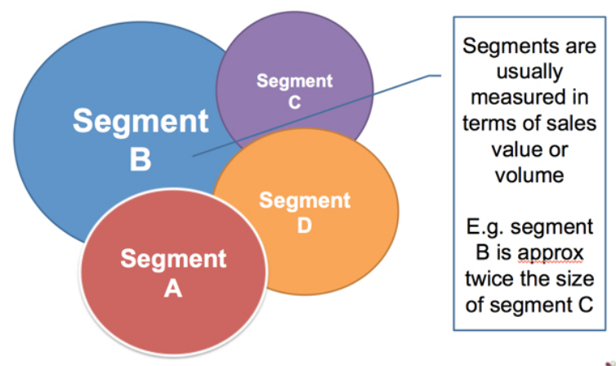
Credit: Tutor2u

Key Q): What are the typical methods of Market Segmentation?

Method | Examples
Age | Student cards, lower prices for children/pensioners.
Gender | Targeted cosmetics (beauty products, hair products etc.) at different genders.
Income | Budget products (Sainsbury's Basics, Aldi, Lidl) at low income/budget conscious consumers
Location | Expensive fuel at service stations on motorways, soft drinks more expensive in beach cafes. McDonalds more expensive in London/cities than in Chirk.
Lifestyle | Hobbies and interest groups.  Products targeted at music lovers, animal lovers etc.

Key Q): Why should businesses use market Segmentation?

Better matching of customer needs | Customer needs differ. Creating separate products for each segment makes sense
Enhanced profits for business | Customers have different disposable incomes and vary in how sensitive they are to price. By segmenting markets, businesses can raise average prices and subsequently enhance profits
Better opportunities for growth | Market segmentation can build sales. For example, customers can be encouraged to "trade-up" after being sold an introductory, lower-priced product
Target marketing communications | Businesses need to deliver their marketing message to a relevant customer audience. By segmenting markets, the target customer can be reached more often and at lower cost
Gain share of the market segment | Through careful segmentation and targeting, businesses can often achieve competitive production and marketing costs and become the preferred choice of customers and distributors

2.4 The Marketing Mix

Think of the Marketing Mix like a big mixing pot of strategies and techniques that a business can use to market its products in order to increase customer awareness or boost sales.

It’s made up of the “4 P’s”, which are: Price; Product; Place and Promotion. Each one has a range of strategies associated with it to help with marketing activities and these are outlined below.

2.4.1 Price

Key Q): Why is price important?

Most consumers are very sensitive to price as they are limited by their income (the money they make). Therefore, they will look closely at the price before making a decision to purchase, ensuring they are spending their money wisely.

Key Q): Which factors affect the price of different products and services?

There are lots of reasons a price may need to change, but some of the most common are:

- Changing prices in line with competitors to make sure customers don’t go to rivals.
- New businesses might need to charge lower prices to attract customers to their business.
- All businesses might face issues with costs rising that may lead to them raising their prices.

Key Q): What are the various pricing methods used by businesses and their advantages and disadvantages?

Pricing strategies are the different techniques businesses can use to decide upon their prices depending on their changing situations.

Competitor Pricing | Prices that match the competition. It’s often used when there are lots of competitors selling similar products.
Cost-plus pricing | Prices that at least cover your costs. A business works out the cost of producing a product then sets a price to ensure a profit.
Penetration Pricing | Prices set really low when a business’ products are new to “penetrate” the market and drum up interest, taking customers away from the competition.
Price Skimming | High prices for new and high quality products to gain as much revenue as possible before dropping them later. These prices will often be higher than the competition
Promotional Pricing | Prices to promote a product, such as BOGOF, 40% off etc.  These are often added for short periods and used to sell off old stock.

Competitor Pricing | Prices that match the competition
Advantages | Disadvantages
Ensures the business stays competitive | Forces a business to compete on other things than price, like quality, which it may not be able to do.
Avoids pricing below/above competition which can lead to damaging price wars. | May only just cover production costs which may lead to low profits.

Cost-plus pricing | Prices that at least cover your costs.
Advantages | Disadvantages
Easy to calculate | Might not match the competition’s prices.
Ensures all costs are covered | Profit is missed if prices are set to low, below what customers are really prepared to pay.
Prices increases can be justified when costs rise. | Businesses don’t worry as much about keeping costs down, they’ll just a price to cover it.

Promotional Pricing | Prices to promote a product, such as BOGOF or 40% off. They don’t always directly change the price, but always have the effect of lowering the price
Advantages | Disadvantages
Earns revenue on out of fashion goods that would probably not sell otherwise. | Revenue is lower on each product, so profits will be lower (or non-existent).
Can renew customer's interest in products with falling sales. | When attempting to renew interest, can be risky if sales don't rise

Price Skimming | High prices for new and high quality products to gain as much revenue as possible before dropping them later.
Advantages | Disadvantages
High prices can give a product a good image, and give customers the impression that it is very high quality. | Competitors may bring out a lower-priced product, taking away your market.
Will give firms high profits while the price is high, helping to pay back research and development costs. | Some sales may be lost because customers are not willing to pay the higher price.

Penetration Pricing | Prices set really low when a business’ products are new to “penetrate” the market and drum up interest.
Advantages | Disadvantages
Will attract customers to the product and make them want to try it. | Revenue is lost while the product is selling at a lower price.
Good for increasing market share quickly. | Not good for products with short product life cycles.

2.4.2 Product

Key Q): Why is analysing the Product Important?

- It’s really important for businesses to create products that customers want. It’s vital to make sure that once you’ve done your market research, you create the right product.

- The product will also need to be the right balance between:
- The cost to make it.
- The function of the product
- The way the product looks

Key Q): What is the difference between Invention, Design and Innovation?

Inventions are brand new designs for products or ideas for services.

Most of the time, products or services will be innovations and improvements on current products and designs.

Business will spend lots of money on Research and Development to either invent new products or innovate and develop the designs of current products

Vast sums of money will then be spent on the image and the branding around the product to help consumers understand what’s on offer and encourage them to buy it.

Key Q): What is the Product Life Cycle?
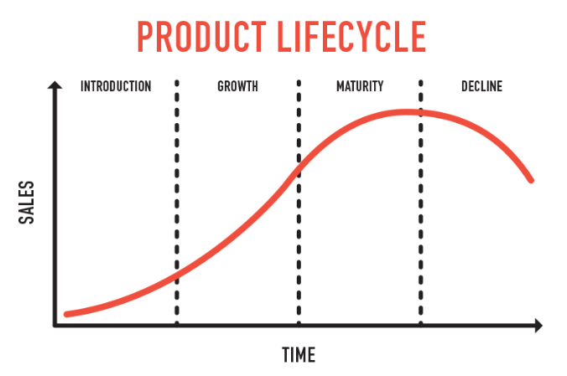
Credit: AssignmentPoint.com

Key Q): What are the stages that products go through in the product life cycle?

Introduction – researching, developing and then launching the product

Growth – when sales are increasing at their fastest rate

Maturity – sales are near their highest, but the rate of growth is slowing down, e.g. new competitors in market or saturation

Decline – final stage of the cycle, when sales begin to fall

Key Q): What are Extension Strategies to the Product Life Cycle?

Extension strategies extend the life of the product before it goes into decline.

Again businesses use marketing techniques to improve sales. Examples of the techniques are:

Advertising – try to gain a new audience or remind the current audience.

Price reduction – more attractive to customers

Adding value – add new features to the current product, e.g. improving the specifications on a smartphone

Explore new markets – selling the product into new geographical areas or creating a version targeted at different segments

New packaging – brightening up old packaging or subtle changes
Credit: AssignmentPoint.com

2.4.3 Place

Key Q): What is place and what does it cover?

Where products and services are sold
This covers corner shops, high street shops, shopping parks, supermarkets and online shops and the changes these have seen.

The distribution channel and how products are delivered
This covers how the business gets its products out to its consumers.

Key Q): What is the difference between Physical and Digital Distribution?

Physical Distribution | Digital Distribution
The most common type of distribution.  It is the movement of goods that we can see, for example:  - Household products made in a factory and sent to a shop  - Food grown by farmers and sent to consumers  - Products mined from the ground and turned to finished products like steel. | As the internet has grown, more products are now sold digitally, with no physical movement of a good, the most typical digital good will be a download.

Key Q): What are the advantages and disadvantages of Digital Distribution?

Advantages | Disadvantages
Customers have 24/7 access to goods.  Goods are available quickly (download)  Businesses save costs as they have no physical product to store/deliver. | Not all goods can be downloaded.  Businesses may be forced into this, requiring large set up costs to set up the technology required to do so.  Not all customers have access to internet or fast internet.  Digital downloading has increased amount of illegal material shared

Key Q): What are the most common distribution channels?

The following distribution channels contain the following groups of people/businesses:

Producer | A person, company, or country that makes, grows, or supplies goods or services for sale
Wholesaler | The business of selling of goods in large quantities and at low prices, typically to be sold on by retailers at a profit:
Retailer | A person or business that sells goods to the public in relatively small quantities for use or consumption rather than for resale.
Consumer | A person who consumes a good or service.

The most common types are:

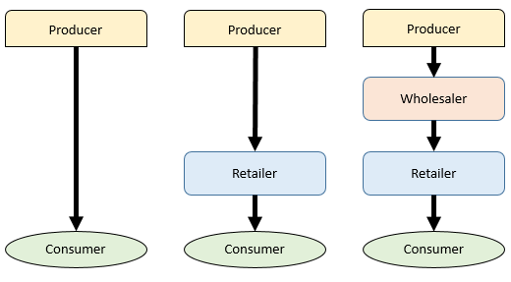

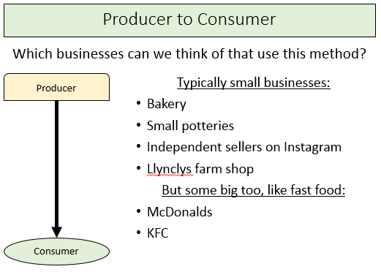

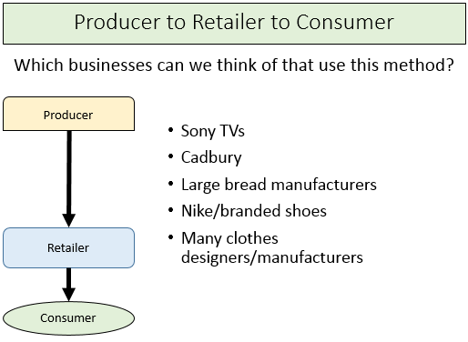

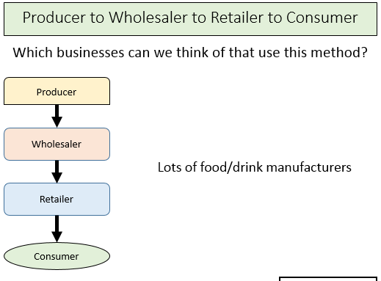

2.4.4 Promotion

Key Q): What does Promotion aim to do?

- Inform customers about a product or service
- Keep a business ahead of its competitors
- Create or change the image of a business
- Maintain or increase sales

Key Q): What are the different methods of promotion available to a business?

- First are “Point of sale promotions” where the promotion takes place where the product is sold. These include:

Price Reductions | Reducing the price of a product to attract more people to the product.
Loss Leaders | To have a popular product sold at a loss, so people are attracted into the shop, purchasing other products that make profits.
Competitions | Competitions ran by a business to win certain products in the hope that customers will buy other products whilst taking part in the competition.
Free samples | Giving away free products or tastes of products in the hope that customers will purchase full versions.

- Next is advertising promotion, which includes:

- Social Media
- Websites
- Printed Media
  - Newspapers
  - Magazines
  - Leaflets
- Television
- Radio

Key Q): Of the above advertising and promotion methods, which is best?

Making a choice here will depend upon:

- The cost of using the method

Typically, advertising through smaller newspapers, magazines, leaflet and radio stations will be cheaper, but reach less people.

Social media can be relatively inexpensive if used carefully, but it can be very expensive to reach a large audience.

- The number of people the method is likely to reach.

The more popular the method, the more people it will reach.

Social Media has a growing audience.

Traditional methods such as magazines and leaflets are experiencing a decline.

Newspaper, TV and Radio remain strong but aren’t as popular as they once were.

- The type of people the method will reach – Age, Income etc.

Social Media is excellent for businesses who want a younger audience. Whereas more traditional methods, such as Radio and Newspaper, may be more appropriate for an older audience.

Unit 3 People

3.1 The Role of Human Resources

Key Q): What is the purpose of the Human Resources Department?

The purpose of Human Resources is to carry out and monitor the human –related functions/activities of a business. Human Resources recruit the right employees to meet the needs and look after them when they’re employed.

Key Q): What are the typical problems of having a Human Resources Department?

- Cost of paying staff to review the HR needs, money that is then not spent elsewhere
- Time needed to find/employ the right people.

3.2 Organisational Structures and Different Ways of Working

3.2.1 Organisational Structures and Charts

Key Q): What is an organisation chart/structure?

An organisation chart is a way of displaying an organisational structure. They show how responsibility is organised in a business, showing who has which roles and who is in charge of who.

Key Q): What are the two key organisation structures?

These are tall and flat. Tall refers to lots of layers of people, whereas flat has very few layers.

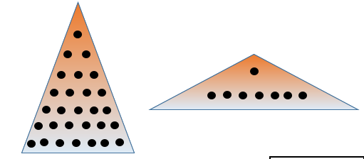

Key Q): What are the advantages and disadvantages of the structures?

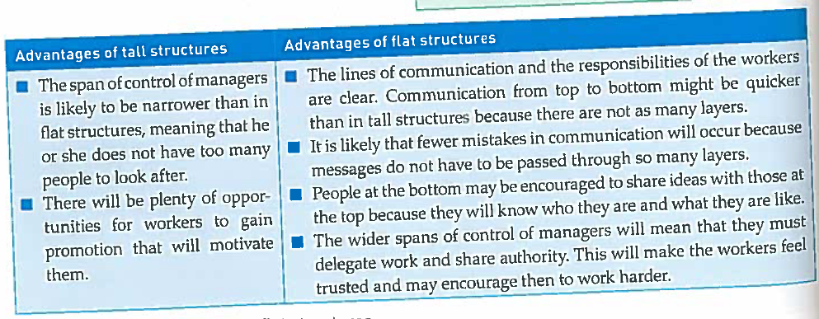
Key Q): What are the key terms you need to know for Organisation Charts?
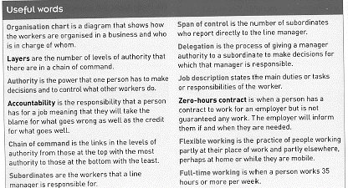

Key Q): How do the organisation charts work?

The departments in the business are organised by function, so each department has a specific job to do.

There is a hierarchy to the business, with several layers.

Employees higher up the organisation have more responsibility and authority that those on the layers below.

Authority is the power to make decisions.

Ways of Working: part time and pull time working

Key Q): What is the difference between part time and full time working?

Full Time
Full time is generally thought of as 35 hours per week and more.
Full time is the traditional and most common type of employment in the UK

Part Time
Part time is seen as 35 hours per week and less.
Part time work is growing fast with the introduction of zero hour contracts, where workers have no minimum hours but will be asked to work at any given time.

Key Q): What is meant by temporary working?

Temporary working is also known as casual labour. Workers work for a business for a short period of time, they may agree to a fixed-term contract, for three months for example. They may also just work when called in. It is common in seasonal businesses where workers will be called in when demand for products is high during the summer or over Christmas.

Key Q): What are the advantages and disadvantages of part time and temporary working?

 | For the worker | For the business
Advantages | - Suits people who need to look after their families.  - Suits semi-retired workers who do not want to work a full week.  - Suits students who want to earn whilst they study. | - Experience workers, such as those retiring, can still stay and contribute to the business.  - The business may have more choice by offering part time work as not everyone wants full time work.  - The business can respond to seasonal changes in demand by hiring more workers during busy months, such as Christmas.
Disadvantages | - Part time work may mean a lower income for a worker who’d prefer full time.  - Workers may be uncertain of income if they don’t have fixed hours.  - The hours may be inconvenient for the worker, such as 3 hours in the morning and 2 later in the afternoon. | - Recruitment and training costs might be higher as more part time workers may be needed to do the job of fewer full time workers.  - Managers may have more workers to manage, leading to higher stress levels and less time to complete other jobs.

Key Q): What is meant by flexible working?

Flexible working refers to working outside of a normal working pattern, which would typically be along the line of 9-5. It includes:

- Zero Hours Contracts, where the worker has no fixed hours, but works when they can and when the business has work for them.
- Working from home for part of the week
- Working flexi-time, where the worker has a set number of hours to work a week and they can work them however they like, such as all in four days.
- Shift working, such as where a worker works 8am-8pm for three days, has three days off, then works 8pm-8am.

Key Q): What are the advantages and disadvantages of working from home?

To the business |  | To the worker
Advantages | Disadvantages | Advantages | Disadvantages
Workers can work longer as they travel less. | The worker may not be able to share ideas with colleagues who are in work. | The worker may have freedom about how much and when they work. | The worker may miss out on the motivating social side of being in work.
Workers may be more motivated because they have the freedom to manger their workload at home. | The worker may produce less without the discipline of being in work and with the presence of distractions. | The worker may save money in travel costs
Workers may work better if there are fewer distractions at home than in the workplace. | The worker may need to be trained in the technology needed to work from home, training a business may need to pay for. | The worker may experience less stress by not having to travel to work or be in the working environment.

Key Q): What is meant by self-employment?

Self-employment refers to those workers who work for themselves and provide their services to other people or businesses. This gives them the flexibility to work when they want, on the jobs they’d like to work on. It can also businesses as they only pay self-employed workers when they need them, keeping costs down. Common examples are plumbing, electricians, bricklaying and taxi driving.

3.3 Communication in business

Key Q): Why is communication important?

- Communication isn’t just about getting instruction out around the business, it:
- Motivates employees, keeping them feeling a part of the business.
- Keeps different departments working towards the same goal
- Makes decision making easier and better, with accurate information being used.
- Keeps customers up to date with changes, boosting sales.
- Improves relationships with suppliers, possibly leading to lower costs.
- Improves your relationships with investors and banks, making lending more likely.

Key Q): What are the different ways of splitting communication up?

- Internal and External

- Horizontal and Vertical

- Formal and Informal

- One-way and Two-way

Key Q): What is the difference between internal and external communication?

Internal Communication Methods | External Communication Methods
Between people in the same business | With people outside the business
Formal meetings and briefings  Emails  Intranets  Blogs  Podcasts  Intranet (in business internet)  Informal meetings  Conference calls  Internal newsletters/brochures  Message boards  Training Materials | Press releases  Social media feeds  Online videos  Adverts  Brochures  Email  Letters  Accounts  Telephone calls  Reports to government etc.

Key Q): What is the difference between horizontal and vertical communication?

Vertical occurs between a superior member of staff and a subordinate, either up or down the hierarchy.

Horizontal occurs between employees on the same layer of an organisation.

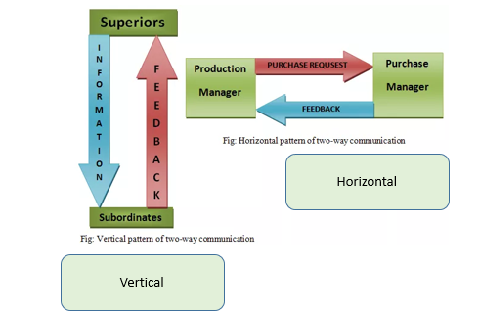

Key Q): What is the difference between formal and informal communication?

Formal Communication takes place when the means of communication are through official channels, like letters, meetings and reports.

Informal occurs as conversations during break, but can be just as important.

Key Q): What is the difference between one-way and two-way communication?

One-way counts as communication without any response expected from the receiver.

Two-way is the communication that occurs as conversations. Responses are expected from the receiver.

Key Q): What stops effective communication from occurring?

- Insufficient communication leaves staff and customers “in the dark”, demotivating them and leading them to lose interest in the business.
- Communication can fail when:
- A message is unclear.
- The sender is unable to use the communication methods.
- The receiver is unable to use the communication methods.
- The receiver is demotivated and unwilling to listen.
- There are unclear or long lines of command in a structure.

Key Q): How has technology affected communications?

Department | Impact
Marketing | Websites and social media to advertise & online selling.
Human Resources | Growth in mobile working, online job applications.
Operations | Machines now exist that produce much more data on errors, improving quality, customers can manage their accounts via apps.
Finance | Digital communication helps to manage accounts, using software to create and send any bills etc. very quickly.
Employee performance | Workers can share ideas far quicker and spend less time waiting for responses, meaning better process happen, improving employee performance.
Competition | Companies can now work around the globe, expanding and producing in different countries, increasing globalisation of the world.
New business opportunities | Businesses have sprung up that make the computers necessary to communicate, train staff and develop even better methods!

3.4 Recruitment and Selection

Key Q): What is “Recruitment”?

The process of hiring staff with specific skills to perform specific duties within the business.

Key Q): What are the main reasons behind businesses needing to recruit?

Starting up or Growing | Recruiting workers to meet the needs of the business that’s in the process of launching.
Replacing any staff that are leaving | Staff will leave for a whole host of reasons, but will naturally leave a gap once they’re gone. It’s vital to make sure these gaps are filled by people who have the same capabilities.
Filling in any skill shortages | Some businesses will require very specialist workers, like highly trained engineers or doctors. Finding these can be tough if there is a shortage in a country, so often firms need to look abroad.  Brexit has thrown up lots of interesting problems with this one, including  - Still encouraging enough foreign doctors to apply/come to the UK  - Still encouraging low skilled workers to come and work fruit picking etc. Farming makes lots of money in the UK.

Key Q): What is the process of searching for and then recruiting the right workers?

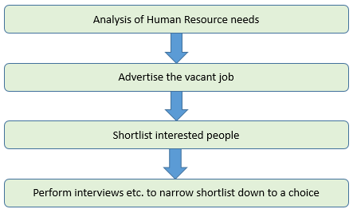

Key Q): How do businesses choose which people to shortlist and offer an interview to from all the applicants?

Any one or all of the following:
- Reading application letters
- Application Forms
- Reading CVs
- Contacting references (people who talk about/recommend the applicants).

Key Q): How do businesses then choose from those they interview?

Any one or all of the following:
- Contacting references (people who talk about/recommend the applicants).
- Performing interviews
- Using tests or presentations
- Carrying out group activities

More demanding jobs or jobs that require more specific skills are likely to use tests and activities, whereas lower skilled work will require less difficult tasks, maybe just using CVs and interviews.

Key Q): What are the specific advantages of using each of the selection methods?

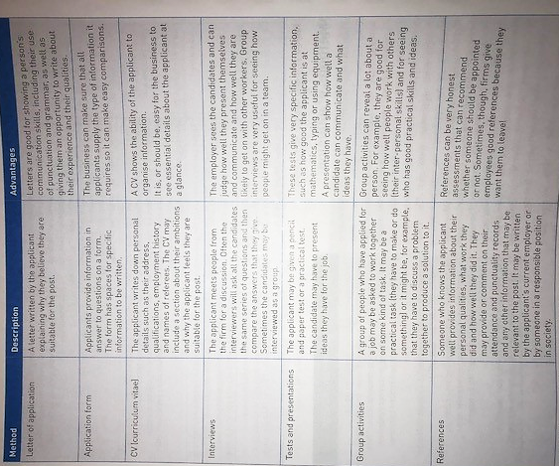
Key Q): What’s the difference between a Job Description and a Person Specification?

Job Description | Person Specification
This lists the tasks and the responsibilities the worker must perform. Writing this helps the business understand the work it wants its employee to do.  It’s also important in ensuring the potential employee is clear about whether the job is right for them. | This is the list of qualifications, attributes and traits an ideal employee should have to be able to complete the job.  It’s likely to include Leadership, initiative, resilience, organisation, good communication skills, good GCSE grades etc.

Key Q); What is the difference between Internal and External Recruitment

Internal recruitment is when a job vacancy is filled by somebody who already works for the business.

External recruitment is when a job vacancy is filled by employing somebody from outside the business.

Key Q): What are the advantages and disadvantages of using Internal and External Recruitment?

 | Internal Recruitment | External Recruitment
Advantages | - Often cheaper to advertise internally.  - Usually quicker to employ someone who’s already in the business.  - The person employed will already have a good knowledge of the business, how it runs, requiring less training.  - Can be good for morale if workers know they have a good chance of internal appointments/promotion. | - Brings in fresh ideas from people outside the business.  - Doesn’t cause tension between employees vying for the same role.  - Helps to bring new skills that fill current skills gaps.
Disadvantages | - Existing staff may not have new ideas that help the business grow.  - There may be a lack of people internally who have the necessary skills.  - Jealousy and resentment may be created amongst those workers who don’t get the role.  - The job of the promoted worker may need filling. | - Usually takes longer than internal recruitment.  - Will usually cost more.  - New candidates may need training.  - New employees may turn out to lack skills, something you can’t see without knowing the candidate well. (Can talk the talk, but can they walk the walk?)

Key Q): What should be included in a Job Advertisement?

Key Q): How do businesses choose where to advertise?

The choice will come down to X main factors:

- Whether the business wishes to recruit internally or externally.
- The amount of money available to the business to advertise.
- The type of person required.
Jobs that require workers with high or specific skill levels are likely to have fewer applicants. So the business may need to choose job advertising methods that have a wide reach, or a very specific reach. For example, job advertisements for teachers are likely to be in teacher magazines, not in local newspapers.
- The location of the work
The choice of advertisement may rely on where the job is, such as a particular county or country.

Key Q): With that in mind, where can businesses advertise?

Businesses can choose from a range of locations when deciding to advertise it’s recruitment needs.
Internal advertisements
- Bulletins
- Emails
- Noticeboards.

External advertisements
- Online advertisements
- Sponsored advertising where businesses pay to have their jobs appear highest and the business pays depending on how many click on the ad.
- Organic advertising where jobs appear in a natural order, usually alphabetically or by expiry date (when the job ad expires).
- Social Media
- Local Newspapers
- National Newspapers
- Specialist Magazines
- Job Centres
- Word of mouth

Motivation and Retention

Key Q): What is motivation?

Methods used to encourage hard-work amongst workers, increasing their productivity.

Key Q): What is retention?

When workers choose to stay with a business rather than move elsewhere.

Key Q): What is productivity?

A measure of output per worker and is used to measure the effectiveness of a worker. The more a worker produces per time, the more effective they are.

Key Q): Why is motivation important to a business?

High employee performance | Happy workers will be productive. This will lead to higher output for lower cost, increasing profitability of the business.
High retention and low turnover of workers | Happy workers will feel valued and will be more likely to remain. Keeping your best staff is vital, it keeps vital knowledge inside the business and reduces costs of training/employing new staff.
Ease of recruitment of new workers | As word spreads of the motivating and valued nature of working for a business – more staff will want to join. Businesses with poor motivation and retention will typically find it difficult to hire new workers.
Less need to supervise workers | Motivated staff will focus better on their work, requiring less supervision – this improves their performance further, increasing output whilst lowering cost.

Key Q): Why is motivation important to a business?

Low absenteeism | Motivated staff will be absent less often, saving the firm money in sick pay, disciplinary methods and reduces the amount of wasted/missed production.
Reduced waste of raw materials | Motivated staff will produce good quality work, making the best use of resources.
Better delivery of services | Motivated staff will give better customer service, improving the image and ultimately the popularity and profitability of a business.

Key Q) What are the main financial methods of motivation a business can use?

Pay:
How does pay motivate?
Pay allows workers to buy the goods and services they need to improve their standard of living.
It’s also important in keeping workers from going to competition with higher pay.
Workers will feel valued and will be motivated to do their job well.
Salary  This is where workers are paid a set sum per year, with payments paid out in 12 equal monthly payments.  Salaried workers are often motivated by promotion potential and high salaries attached to higher jobs. | Wages  This is a more simple method, where workers are usually paid weekly.  Workers will work a certain amount of hours, then the weekly pay is calculated.  Eg. £10 per hour x 40 hours per week = £400 per week.
Problems
Pay is a cost, it doesn’t depend on output and encourage to produce a higher output.

Profit Sharing:
How does profit-sharing motivate?
A proportion of a company’s profits are held to the side and shared with workers. The higher the profits, the more pay a worker gets. This motivates the worker to work harder and increase profits.
For example:
10% of £5,000,000 profit may go to workers.
This means £500,000 is given to workers.
If there are 160 workers
£500,000/160 = £3,125 per worker.
Problems
Pay is always cost – high sharing rates might reduce the profits that doesn’t satisfy business owners.

Bonuses

How do bonuses motivate?
Workers receive bonuses on top of their standard pay.
They will be linked to performance and motivate staff to perform well and achieve their bonus.
For example:
A worker may receive a £1,000 bonus if they produce a certain amount of products or reach a certain level of sales.
Problems
Targets must be realistic or workers won’t be able to hit them.
Big bonuses given to top staff can anger employees lower in the system and cause demotivation amongst “shop-floor” workers.

Fringe Benefits

How do fringe benefits motivate?
These are other benefits given to workers that still have a cost to the business.
These extra benefits improve the happiness of the worker and keeps them motivated.
For example:
Car allowance, company car or fuel payments.
Pension schemes the worker can use once they’re retired.
Childcare vouchers.
Private medical insurance.
Free/half price lunches.
Problems
These can be costly to a business, reducing their profits.
Not linked to performance, so may not increase output.

Key Q): What are the main non-financial methods of motivation?

Method | How it works
Praise | - Words of praise lead to workers feeling good and feeling valued.  - Public words of praise motivate the staff and provide examples to others.  - Happy and valued workers and more likely to work hard.
Award Schemes | - These are linked to praise.  - They will be handed out in recognition of good work, giving the feel good factor and leaving a worker feeling valued.  - They can be as simple as well done badges or linked to free holidays and vouchers.
Working Environment | - Safe places of work, with good heating and lighting motivate workers to work harder.  - Good staff happiness, where workers are positive and have a can do attitude improves motivation.  - A workplace where team work thrives and workers get along through compromise, understanding and support will also raise motivation

3.6 Training and Development

Key Q): What is the difference between Training and Development?

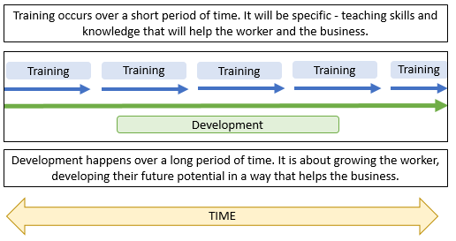

Key Q): What are the different types of training?

Training
Induction Training | Training to introduce a new worker to the business, place of work and their fellow workers and their new job requirements.
 | Advantages to worker  - Workers get to know new colleagues and feel welcome.  - Workers learn about the facilities and how the business runs.  - Workers learn their duties in the business and how to perform them. | Advantages to business  - When the worker settles quicker, they produce output more quickly for the business, increasing profits.  - Health and safety issues can be reduced as the worker has learnt about hazards etc. around the workplace.
Disadvantages
Workers will still be paid whilst receiving their induction training, but won’t have a chance to produce any output for the business.

On-the-job Training | Training that occurs in the workplace and whilst the worker is doing their job.
 | Advantages  - Individual training is given that improves performance  - Cheaper than off the job training as there is no travel and accommodation cost,  - Trainee still produces goods for the business so the business continues to earn money. | Disadvantages  - The trainer may need to leave their work to deliver the training, so their output falls.  - A trainee’s work may be low quality, harming business reputation.  - The trainer may only learn skills useful for that business, meaning they can’t use them elsewhere.

Off-the-job Training | Training that occurs away from the job. It may still be at the place of work, or the employee may go on a course out of the business.
 | Advantages  - Experts may provide the training, making it high quality.  - Workers often enjoy the change of environment, boosting motivation and productivity.  - Workers may feel more valued as money is spent on their development. | Disadvantages  - Usually more expensive as an external business will provide the training.  - The absence from work means the worker is not producing goods or services for the business when training.  - There is a risk that the employee may want to leave the business once they have new skills.

Key Q): What are the different types of Staff Development?

Staff Development
Apprenticeships | A long term development programme for workers to learn job skills while they work through a mixture of on-the-job and off-the-job training and study. Apprenticeships will lead to some sort of vocational (hands-on) qualification.
Professional Development | This includes vocational and academic development. It involves learning over a long period of time. Workers will learn from on-the-job and off-the-job training, it can lead to qualifications, but not always, and can be completed at any time, leading to a better skills/potential of the employee.

Key Q): What are the key benefits of training?

- Development of the business
- Improving productivity
- Solving skill shortages
- Improving customer services
- Improving motivation and retention

3.7 Employment Law

Key Q): What are the main employment laws you need to know about?

The 2010 Equality Act

The 2010 equality act was created to ensure that nobody was discriminated against (treated unfairly) in any of the following ways

- Equal Pay Discrimination: Paid any less because of gender.
- Racial Discrimination: Refused a job or treated unfairly because of Race.
- Sex discrimination: Refused a job or treated unfairly because of gender.
- Disability Discrimination: Refused a job or treated unfairly because of disability.
- Sexual orientation Discrimination: Refused a job or treated unfairly because of sexuality.
- Religion or belief discrimination: Refused a job or treated unfairly because of religion belief.

Key Q): What can a worker do if they feel unfairly treated?

They may go to an employment tribunal.

Here, a panel of qualified lawyers, judges and other law professionals will debate either side of the case. If the employee is found to have been unfairly treated, they can be awarded compensation and costs whilst the business can be fined.

The employee can seek support and advice from a trade union at all times, so long as they are a member.

A Trade Union is an organisation that exists to help and support its members.

Key Q): How many days of holiday is a worker entitled to?

In the UK, employment law states that all workers are entitled to 5.6 x the amount of days worked a week of holidays per year, including bank holidays.

So if a worker works 5 days a week, they are entitled to 5 x 5.6 days holiday a year, which is 28 days.

If a worker works 6 x 5.6 days a week, they are entitled to 6 x 5.6 days holiday a year, which is 33.6 days per year.

Key Q) How many hours is an employee permitted to work per year?

The “Working Time Directive” employment law limits the number of hours an adult worker can work to an average of 48 hours per week over 17 working weeks.

The limit is 40 hours or 8 hours a day for someone under 18.

Workers must also be given a 20 minute break for every six hours worked

Exceptions

People may choose to opt out of this law, but if there is evidence of them feeling forced to do so, a business will face legal action.

Those in the armed forces, police, emergency services, security workers and servants in private households can also be directed to work more than 48 hour weeks.

Those workers in charge of businesses (sole traders or directors for example) may also work more than 48 hour weeks – the law doesn’t apply to self employed people.

Key Q): What is a contract of employment?

A contract of employment is a legal agreement between two people.
When a person offers work and another accepts, a contract has been made.
The employment rights act of 1996 states that a written contract doesn’t need to be generated, but a statement of employment particulars must be handed to the worker.

The statement of particulars should include:
- Job title
- When employment began
- Hours that should be worked
- Typical duties of the employee
- Pay and holiday given to the worker.

Key Q): How does employment law impact a business?

Benefits
- Workers will see the business as a good employer and will be more motivated, doing a better job.
- The business can attract new employees more easily as they have a good image.
- Workers are more likely to stay, reducing costs of employing new workers and keeping the best skills in the business.
Costs
Cost | Explanation | Example
Wage Costs | Businesses may have to hire more workers than they would like. | There’s a limit on the hours they can ask current workers to do OR they need to let current workers have holidays
Wage Costs | Businesses will need to employ workers to ensure the employment acts are abided by. | Workers will need to ensure policies are in place that abide by employment laws and write contracts of employment.
Court Costs | An employee may take legal action against a business, costing the business money in lawyers to represent it in court. | The worker takes a firm to court for discrimination.
Fines | If the firm is found guilty of breaking employment laws, they may need to pay a fine. | A firm found guilty of discrimination pays a fine to the worker.
Publicity Costs | Negative publicity can arise about the employer that is reported across newspapers and TV news channels | A firm found guilty of discrimination may then find it hard to employ workers in the future.

PAPER TWO

Paper 2

Unit 4 Operations

4.1 Production Processes

What are production methods?
Businesses can produce their products in three different ways – Job, Batch and Flow Production. Each has its advantages and disadvantages and will suit different business and products.

Key Q) Is there a right or wrong way to produce your products?

No. Every business and product will be different. You need to consider the business in the case study and make a decision which production suits them best, giving them the most advantages and least advantages.

Job Production
What is it?
This is the process of production where products are made individually.

Which businesses does it suit?
This suits businesses where a product needs to be bespoke (suited) to different people, or where access to large machinery is difficult due to its cost.

What are the most common examples?
Bridge Building, Wedding Cakes, Wedding photography, paintings, pottery, tailor-made suits or dresses, hairdressing…

What are the main advantages and disadvantages?

Advantages | Disadvantages
Products match individual customer needs, for which you may be able to charge a higher price. | Difficult to make large amounts to satisfy lots of customers, meaning you may miss out on potential sales.
Products are usually of a high quality. | Cost of production might be high, as you may need highly trained/skilled workers and lots of specialist equipment.
Workers can get high satisfaction from making a quality product.

Batch Production

What is it?
This is where one type of product is made in a batch (a group) and then production is switched to make a different batch of products.

Which businesses does it suit?
This will suit businesses who have different variations of products, but have lots of demand for each. Making in batches allows the business to create lots of one, then switch to another.

What are the most common examples?
Bakeries (bread – GREGGS!), Furniture, Books, Newspaper, TVs, Toasters, Laptops.
All these will have one type made, before switching designs but using the same machines.

Advantages | Disadvantages
Can still address specific customer needs (e.g. size, weight, style). | Time lost switching between batches – machinery may need to be reset, is time not spent making a product that can be sold.
Use of specialist machinery & skills can increase output and productivity. | Need to keep stocks of raw materials, which can cost money in storage costs.
Making in batches reduces unit costs as fixed costs are spread over a bigger output. | Can be de-motivating for staff if the production method involves boring, repetitive work.

Flow Production

What is it?
This is where one product is produced continuously using a production or assembly line – it’s sometimes called mass production.

Which businesses does it suit?
This suits businesses that have very high demand for a product that can be made quickly on an assembly line. Making so many, so quickly, reduces the cost of each one and means you can sell lots, boosting revenues and profits!

What are the most common examples?
Large car manufacturers (Ford, Honda etc.), glass frames and doors, Coca-Cola.
There may be crossovers with products made in batches, but flow is reserved for the really high demand products!

Advantages | Disadvantages
With lots of machines used and few workers, high numbers of products are made at a low cost. This reduces unit costs, letting a business benefit from economies of scale. | With such high machinery, making any changes to the procedure can be very difficult, meaning your product is hard to change to suit changing customer needs.
With fewer workers, there is a reduced chance of human error and a higher chance of accuracy, improving the quality of the product and potentially the number of sales and revenue. | The high amount of machinery that you need may require very high investment, which could be money you don’t have.
 | The production can be very boring and de-motivating for workers, who may leave, speak negatively of their job or begin to make mistakes in the jobs they do have.

Automation and The Influence of Technology on Production

Production in many industries can now be controlled automatically by programming computers to control machinery.

Lots of tasks have now been automated, where they are completed automatically by these computers and machines.

Workers have new roles in these processes, either programming, designing or controlling the computers.

A key part of automation has been the rise of robotics. These robots complete tasks tirelessly, with no errors (so long as there’s no errors in their programming!)

Examples of technology in business
- Auto-Pilot on a plane
- Payments between bank accounts
- Apple Pay
- Contactless payment
- School data on attendance
- Cars
- Loads of food products
- Insurance products
- Health services
- Delivery of energy to your house

Advantages and Disadvantages of Automation and Technology in Productoin

Advantages | Disadvantages
Costs are reduced as the number of workers needed are reduced, potentially increasing a business’ profits. | Some workers will be made redundant, which means their jobs are declared as no longer existing, so they lose their jobs. This can be a cost to businesses who have to pay redundancy payments and leaves people without incomes.
More goods can be produced and sold, increasing revenues. | Businesses might need to employ highly-skilled workers to use the machines which can be very costly.
Machines are often more accurate than humans, especially at higher speeds. This reduces errors and wasted products whilst making products a higher quality, increasing their potential selling price. | The machines themselves may cost lots of money, increasing short-term costs.
Production can be more flexible as machines can be altered to make different types of products (batch production). | Workers may need expensive training to be able to use the machines.
The machinery is never absent, so no down days. | Machines can break down and this break down can lead to lower sales as products aren’t available to sell.
Machines can do the dangerous and boring jobs humans don’t want to, increasing safety and job satisfaction. | Customers may not like the idea of technology and may prefer handmade products.

4.3 Quality of Goods and Services

The importance of Quality

What does “Quality Mean”?

It’s often said the beauty is in the eye of the beholder; a simple saying to summarise the idea that everybody is different with different opinions. This concept carries into quality. Your idea of quality may well be different to that of your best friend or siblings. But, there are three general rules we can apply to decide if something is “quality”.

A product or service must:

- Be fit for purpose.

- Meet legislative rules (laws and standards).

- Meet customer expectations.

How does quality differ between stakeholders?

- Customer
- Consumer
- Owner
- Shareholder
- Employee
- Competitors/Rivals
- Suppliers
- Government (local councils and national government)
- Local Community
- Trade Unions

Every stakeholder will have a different idea of what makes a quality product. It is a business’ priority to ensure that as many stakeholders in as many groups as possible are satisfied and believe the product or service on offer is of a high quality.

Why is it important to provide quality products?

Providing quality products is important because:

- It avoids waste – products aren’t thrown away due to poor quality, reducing potentially higher production costs and by extension, profits.
- It avoids recalls – if products are recalled, postage and storage would need to be paid, along with refunding the customer, reducing profits.
- It boosts reputation and sales – Customers are more likely to return to a business if they produce high quality products, boosting sales, revenues and profits.
- It reduces disrupted production, which boosts the amount of products you can make available for sale.

Quality Assurance

Quality assurance is an approach that involves the whole business focusing on quality, thus aiming to prevent quality problems from arising.

This is about changing the way things are done within a business to prevent problems with quality happening in the first place.

This can be achieved by:

- Creating a culture in a workplace where everyone is involved in producing quality products or services.

- Training all employees to be able to create a high quality product.

- Asking employees for their ideas and opinions on how to improve a product and then using these to make improvements.

Advantages | Disadvantages
There may be less wastage as mistakes are reduced. | It may disrupt production as workers have to slow down to check quality, this might increase production costs and reduce output.
Workers feel valued as they have more responsibility, increasing their motivation and the amount they can produce. | It may cost a lot for a business to train all of its workers to be able to produce to a really high quality standard.
As with any quality system, the business may benefit from an improved reputation for quality and this might increase sales | The extra responsibility that workers have may lead to higher stress and worry, leading to resistance to make the changes and use the process.

Quality Control

This is implementing a system for inspecting the quality of the goods or services produced and that are of a good standard.

Methods that can be used by Businesses (internal)
- Physical inspection of the goods produced by quality inspectors.
- Surveys of customers taken for their views on quality.
- Mystery shoppers deployed in shops to check that staff are offering a quality service.

Methods can that can be used by Lawmakers (external)
- Consumer Rights Act 2015
  - Products must be:
    - of satisfactory quality
    - fit for purpose
    - As described
- British Quality Standards Systems (kitemarks)
  - Products of a high quality are awarded a kitemark to prove they meet legal standards.

Advantages | Disadvantages
It can help prevent faulty goods and services | It does not prevent waste of resources as mistakes are spotted after production.
It is not disruptive to production – workers continue producing, inspectors do the checking. | The process of inspection costs money as quality inspectors will need to be paid a wage.
As with any quality system, the business may benefit from an improved reputation for quality and this might increase sales | It does not encourage all workers to be responsible for quality

4.3 The sales process and customer service

Selling products has taken a journey.

From market stalls and simple trade, to high street stores, to supermarkets, department stores and to internet sales. It’s an ever-evolving landscape.

E-Commerce | The process of bringing a buyer and seller together electronically. It is different from digital distribution as there will be physical element, usually as physical delivery (Amazon
Face to Face | Is usually completed in a shop where there is direct contact between buyer and seller.
Telesales | These are sales that are completed over the telephone.

E-Commerce

The change in technology has been so massive and businesses rely so heavily on the internet now that E-Commerce has become a big part of your GCSE.

What exactly is E-Commerce?

E-commerce is anything that brings together a buyer and a seller electronically but differs from digital distribution as there will be some physical element, like in the delivery of goods. It is also known as online selling, just be careful to keep the separation between digital distribution and e-commerce, digital distribution would just be a feature used within e-commerce.

What are the advantages and disadvantages of E-Commerce to businesses?

Advantages | Disadvantages
Sell world wide – A business can access more markets across the world to sell in. Increasing the amount of sales, revenue and profit it can make. | Worldwide competition – Operating online puts your business up against a wide range of competition that may take sales away. Competitors operating online may also take some of your customers away, reducing your revenues.
Open all the time – Customers can access a business’ products and services at any time. This increases the chance of a sale for the business, increasing chances of revenue, cost and profits. | Problems of delivering goods and accepting returns – Delivery costs of products out to customers can be expensive to cover. It can be equally difficult to process and dispose of any returns.
Professional look at little cost – Creating a high class shop can be expensive. Whereas a high class website can be easier to make, improving a customer’s perception of the quality of the business, increasing chances of a sale. | Online security – When operating a website, you must hold details of customers personal details. If these are stolen you are liable to pay high fines. Therefore, businesses must pay for online security, an added cost of e-commerce that may reduce profits.
Lower Operating Costs – It is generally relatively more expensive to run a shop than to run a website. These lower costs can increase profits so long as you still sell the same amount of products. | Advances in technology – The constantly improving technology that customers are using provides a challenge to businesses as they must keep updating apps and websites to at least match their rivals.

What are the advantages and disadvantages of E-Commerce to customers and consumers?

Advantages | Disadvantages
Price comparison – Customers can compare the price and quality of many products relatively easily compared to on the high street. This gives them a better choice of products and a better chance of getting them for a lower cost. | Lack of personal contact – Some shoppers prefer to have personal contact and discuss the product and its benefits. This can be particularly important when buying very expensive products.
Seven-day availability – Customers who work when physical shops are open can now shop when convenient to them. Giving them more ease to order and purchase what they want. | Problems returning goods – Returning products that don’t meet your needs can be time consuming and costly.
Wide range of products – Customers have access to a much wider range of products, giving them greater choice and a better chance of finding a product that matches their needs and wants. | Only image of goods seen – Customers can’t try a product and see if it meets their needs. Increasing the chances of purchasing a product that doesn’t meet your needs.
 | Security – Personal details can be stolen and used by third parties.

How has E-Commerce influenced business activity?

Factor | Influence
Location | Businesses are no longer restricted by their location. They can either choose to operate from a central warehouse with no high street presence and deliver their products to a wider range of customers, or choose to have a combination of the both.  Either way, a business has to consider how it locates differently due to e-commerce.
New Skill Development | Businesses may well need to train their workers to be able to use new online systems, update website or use the new delivery systems.
Levels of employment | Businesses may need to hire new workers to cope with higher demand for their products or to do any new jobs associated with e-commerce.  They may also need to make workers redundant if their jobs no longer exist due to closing shops and moving online.
Creation of specific departments | Businesses may need to create entire new departments, manage them and employ new workers to work within them in order to operate online.
Delivery options | Businesses may need to offer a new range of delivery options and buy all the machinery and vehicles necessary for this, which can be costly and time consuming.

Face to Face

What is Face-to-Face Selling?

Usually selling through a shop with a customer speaking to sales advisers.

This can significantly improve customer service experience and increase a business’ chance of making a sale whilst giving the customers a better experience, further increasing the business’ reputation.

It can also be done with visits to people’s houses to explain and sell products.

Advantages

- Advice can be given on products so customers get a product that matches their needs, improving their experience and boosting the chances of sales and repeat sales.

- Questions asked and answers.

- Customers feels valued and well served

Disadvantages

- Shops are more expensive to operate than a website (staff, rents, rates etc.), potentially reducing profits.

- Some customers don’t need advice etc. and would prefer online convenience, meaning that shops go unused and would be better placed online as same sales could be made at a lower cost.

Telesales
These are sales that are completed over the telephone.

Advantages | Allows businesses to make more sales as the sales are made outside of usual office hours, increasing sales revenues.
Disadvantages | However, customers can become irritated with amount of calls they receive, giving the business a bad reputation and recuing likelihood of sales and potential future sales.  Customers can’t try their products before they buy them.

Providing good customer service

Good customer service increases a customer’s satisfaction with a business and as a result, a business’ reputation.

This increased reputation is likely to increased chances of sales, revenues and profits. Therefore, ensuring your customer service is of a high quality is very important to a business.

There are three main ways a business can provide good customer service:

After-sales service | A business should provide customers with a good service after a sale is made. This will often include advice and potentially the ability to return or refund goods after a business is obliged to do so or at least exchange products for a working version.
The importance of good product knowledge | A business should also ensure all its employees have a good knowledge of their products and services so they can answer any question customer’s may have, increasing their satisfaction and the likelihood of making a sale.
Customer Engagement | A business should also use social media and other communication methods such as email, telephone and mail to communicate with customers, keeping them updated on developments in the business and any news they’d find interesting. However, they do need to be careful not to communicate too often, as customers may find this irritating.

4.4 Consumer Law

Customer Rights

Customers are protected by the CRA 2015, an act of Parliament that protects customers when purchasing goods and services. According to the act, goods must be, fit for purpose, as described and of satisfactory quality.

Goods and services must be:

Of Satisfactory Quality
Fit for Purpose
As described

Other customer rights:

Rights up to 30 days after purchasing a product?
- Consumers can return faulty products for up to 30 days.
- For downloads (music and apps) either a replacement can be downloaded or refund issued.
Rights within the first six months after purchasing a product?
- If a fault occurs in six months of purchasing it’s assumed that it was there when the product was bought. Therefore, the seller has to prove the buyer caused the fault if they disagree.
Rights after six months of purchasing a product?
- Faults after six months are assumed to not have been there on purchase, so the buyer has to prove the fault was there - which can take a lot of time and be very costly.

Impact of customer rights on businesses
Production of quality goods
Businesses need to ensure they use quality assurance or quality control to ensure that their products are fit for purpose, as described and of satisfactory quality or they may gain a bad reputation, lowering sales.

Safety of goods
Again, businesses need to ensure that their methods of ensuring quality, (control and assurance) are in place and good enough to spot any potential safety issues or they may gain a bad reputation, lowering sales.

4.5 Business Location

Factors affecting choice of location

Businesses will make many important decisions and one of these will be where to locate. As we’ve seen previously, the growth of e-commerce has meant businesses can now make choices to locate in fewer locations and operate mainly online, relying on delivery networks.

Nonetheless, ensuring that physical locations are the perfect balance of cost and proximity to the market is still very important and businesses will look at a range of factors when choosing their locations.

The factors that influence a business’ choice of location will include:

Cost

A business will need to consider the cost of the site when compared to how much sales revenue it is likely to be able to make at that location. If the costs of the site are higher than potential revenues, the business may make a loss.

These costs include:
  - The cost of the site to either purchase or rent.
  - Transport infrastructure and costs of moving parts/delivering goods from the site to your customers.
  - Cost of inputs nearby
A business needs inputs, including workers (labour) and materials (raw materials). They need to ensure that it won’t cost too much to
    - Labour costs
    - Raw materials costs
  - Government and cost
    - Subsidies from Government to reduce cost
    - Corporation tax put in place by government that acts as a cost to businesses. (Brexit may lead to Britain reducing Corp. Tax).

Proximity (closeness) to the market and/or labour
A business will need to consider how close it is to its market, making sure that there will be enough people near wanting to buy their products or use their services. They will also need to ensure that they are near to enough the right type of workers so that they can be employed to do any necessary jobs within the business that are needed for it to run smoothly.

4.6 Working with suppliers

New key terms for procurement and working with suppliers

Supplies – These are the items a business buys in to sell on. They might immediately sell them on as they are, or they may alter/combine them to add value to them.
Suppliers – These are parties that provide goods and/or services to a business, who ultimately use these to run their business in some way.
Procurement – Is the management of the purchasing within a business.
Logistics – This is the management of the transportation and storage of goods.

Procurement and the Role of Procurement
Procurement Is the management of the purchasing within a business. For some businesses, this will be a very large department as lots of different inputs are needed or lots of products are sold, such as grocery stores or car manufacturers. For other businesses this will be a smaller operation and the owner may purchase the stock themselves.

The procurement department will be responsible for choosing what to buy and where to buy it from.

Factors affecting the choice of supplies

Time of the year
Businesses need to choose products that suit the time of year or risk missing out on bestselling products or having items that won’t sell. For example, not buying suntan lotion in the middle of the worst winter for years!

Changes in Technology
Businesses may change supplies due to changes in technology. It’s important a business choose supplies that are the latest in their trend, or they risk losing out to those who have the most up to date products.

Changes in Fashion and Lifestyle
Fashion changes and so must what a business stocks. If a business sells out of fashion items, they risk losing vast sums in stock. Lifestyles also change – the rise in vegan/vegetarian living has seen supermarkets completely change their offerings of food.

The cost per unit and potential for mark up
A business has to make sure that the cost of their supplies is low enough for them to be able to make a profit. For something as simple as a cake sale, the combined cost of all the ingredients must be less than the price you can sell the cake for. For a company like Apple, all of it’s purchases must be less than the total revenue they make from sales.

Choosing Suppliers
When choosing a supplier, a business will need to weigh up the quality of the supplies, the reliability of the supplier, the repudiation of the supplier and the cost of the supplies.

For some businesses, one of these factors may prove to be more important than others. So where a business ends up on this graph may differ from others. For example, for a luxury perfume manufacturer, the quality of the supplier might be more important than the reputation or reliability of the supplier, whereas for B&M home store, the most important factor is likely to be cost of the suppliers.

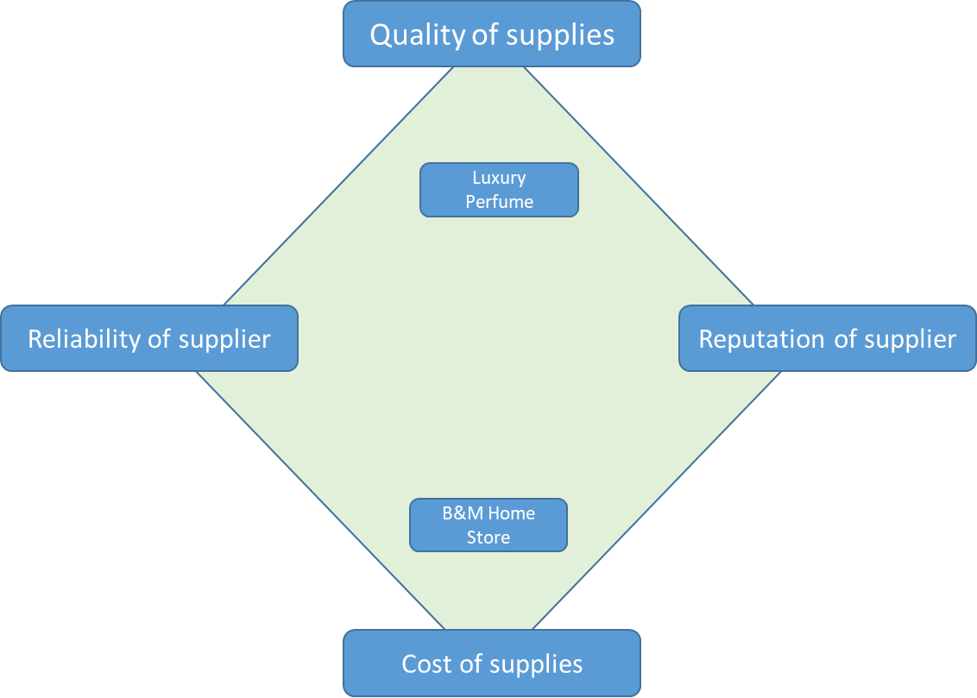

The Length of the supply chain

The length of a business’ supply chain affects how quickly it can respond to changes in demand. If a business needs to procure many different supplies to respond a customer’s changing wants and needs, it can be difficult to do this quickly.

Unit 5 Finance

5.1 The role of the finance function

Purpose of the finance function

Only the largest businesses will have a separate finance function.

Sole traders, Partnerships and smaller limited companies would normally employ an accountant to check their finances. As a business grows larger, it will employ its own staff member or whole staff team to manage its finances.

These workers are likely to have a few specific tasks, including providing financial information to the business owners and supporting planning and decision-making.

Providing financial information

A business will generate a large amount of financial information. This can take many forms and can be used for a whole host of reasons. It will often include:

- The costs and revenues of the business for use in cash flow forecasting and break-even analysis. (see unit 5.5)
- Information on profit or loss of a business, both as a whole and for individual products.
- Data on the average rate of return on different business investments and profitability of different investments (see unit 5.3).

It will be the role of the finance function to ensure that this data is both up-to-date and accurate, so that any decisions that are made as a result of the data are accurate and benefit the business.

Supporting business planning and decision making
As mentioned above, the information on finance will be used for a whole range of reasons, including:
- How many sales a business must make to break-even.
- Whether or not a business can afford to replace equipment.
- If a business can afford to expand and produce more.
- Obtaining a bank loan or persuading a new investor to invest.

Influence of the finance function on business activity

The finance function can influence business activity by providing information that other departments need. For example:

- Whether or not a source of finance can and should be used to help other departments make purchases.

- Whether or not a business will have enough cash in certain month to purchase materials or run an advertising campaign.

- Whether or not a certain product is making a large amount of revenue.

- Whether or not a business can afford to become more environmentally friendly at a potentially higher cost.

- Whether or not a business will be able to respond to a fall in demand for its products during a recession and how it should respond.

5.2 Sources of Finance

Why do businesses need finance?

Business are likely to need finance for a wide variety of reasons that will depend on their size, age and situation.

The most common reasons for needing finance include:

- To establish a business-start-up, which means spending money on equipment, recruiting workers, raw materials and marketing.

- To fund expansion of a current business either via internal or external growth.

- To run business recruitment, paying for the new recruits and the relevant job adverts.

- To develop marketing activities, such as to fund marketing campaigns or maintain or increase sales and market share.

- To run a business on a daily basis, helping with daily running costs and potentially helping sort out longer-term problems of low profitability or even struggles in breaking-even.

The nine sources of finance
There are nine major sources of finance, but a few things to bear in mind.

- Sole traders and Partnerships cannot take on new shareholders, so cannot perform a share issue.
- Limited companies cannot take on extra partners.
- Businesses with poor financial records aren’t likely to be able to get a bank loan.
- Businesses are unlikely to use overdrafts to fund long term projects.

Type of Finance | Medium/  Short/Long term | New or Established businesses? | Description and use | Advantages | Disadvantages
Owner’s Capital | Long Term | New or Established businesses | The owners invest their savings.  This is often used to fund the start-up or an expansion of a business It may be used for other day-to-day activities if a business needs it urgently. | - No need to repay the money.  - No interest to be paid.  - Not cost of raising the finance.  - Quick investment if the owner has the cash. | - Limited to the amount the owner can invest.  - Leaves the owner with lower savings for personal use.
Retained Profits | Long Term | Established businesses | Profits from previous years/months are used to finance current activities  This is often used to buy or replace machinery, fund an expansion of some kind or fund new advertising campaigns. It may be used for other day-to-day activities if a business needs it urgently. | - No interest has to be paid.  - No need to repay the money.  - No cost to raise the finance. | - Only available to businesses that have made profits.  - May anger shareholders who don’t receive a dividend because the money has been used in the business instead.
Sale of assets | Short, Medium or Long Term | Established businesses | Old assets (machines, buildings etc.) are sold and the cash used to purchase new things.  This is often used to purchase new equipment that may be outdated or to help fund expansion. It may be used for other day-to-day activities if a business needs it urgently. | - Good if the asset is no longer used by the business – freeing up cash to be used elsewhere. | - Can take time to sell the asset, slowing down the process of using the money elsewhere.  - May not be able to find a buyer at all.  - Means the asset can no longer be used, which may be a negative further down the line.
Overdraft | Short Term | New or Established businesses | An arrangement with a bank that the business can spend more money that it has in its account.  This is used for day to day expenses like wages, stock and bills where a business is short of cash in one month but will receive new cash inflows later. | - A good fix for short-term cash flow problems, often inexpensive as long as a good arrangement is in place with the bank.  - The business can continue to trade in the short-term, giving it time to improve its cash flow position.  - Quick (as long as overdraft is pre-arranged) | - Interest is charged on the daily amount and can be expensive.  - Doesn’t fix longer term issues that may have caused the cash shortfall in the first place.

Trade Credit | Medium-Long Term | New or Established businesses | The business does not need to pay the suppliers for goods or services for a period of time, often 30 days.  This will be used to buy stock or new equipment without the need to pay immediately. | - Allows a business to buy produce it can sell to a customer before payment is made. This allows the business to make revenue before having to pay for outstanding costs.  - It can help with short term cash flow problems as the business is given time to find cash.  - The period of credit is usually interest free, meaning no additional cost is added on. | - The goods must be paid for even if they’re not sold, putting pressure on the business to sell them within the time given.  - Interest is charged on the credit if the payment is not made in time.
Loans | Medium-Long Term | New or Established businesses | An amount of money borrowed from a bank or other lender, usually for a stated purpose. In some cases, the bank may want to take a security, such as a machine or a building, in case the business can’t pay. The bank would then own this asset and sell it to get its money back. The business will have to pay interest on its loan.  This is often used to fund the start-up or an expansion of a business It may be used for other day-to-day activities if a business needs it urgently. | - Repayments are spread out over a longer period of time, giving the business time to pay off the debt in a manageable way using monthly profits. | - Interest has to be paid.  - Businesses may need to use an asset to secure the loan, putting this asset at risk of being seized by a bank if they can’t pay their loan off.
Taking on a new partner | Long Term | New or Established businesses | A new partner is taken into a partnership, adding funds when they join.  This is often used to fund the start-up or an expansion of a business It may be used for other day-to-day activities if a business needs it urgently. | - New partners may bring skills as well as cash.  - There is not interest/cost to pay on the finance. | - The new partner will have a say in how the business is run and arguments may occur/decisions slow down.  - The new partner will be entitled to share of the profits.
Share issue | Long Term | New or Established businesses | Where a limited company sells shares in return for cash that’s invested into the business. Can be done privately or by public limited companies by selling shares on the stock markets.  This is often used to fund the start-up or an expansion of a business It may be used for other day-to-day activities if a business needs it urgently. | - A lot of finance can be raised if lots of investors buy shares.  - Money doesn’t have to be paid back in a certain time.  - No interest is paid. | - Dividends will have to be paid at some point in time to shareholders.  - Shareholders will have a say in how the business is ran, which can frustrate original owners and slow down decision making.  - Original owners may witness a takeover occur if a new shareholders somehow acquires more than 50% of the business.
Crowd-funding | Medium-Long Term | New or Established businesses | Money is raised from sponsors, usually by advertising a business idea on a crowdfund-raising website.  Sponsors either donate money, lend money or become a part owner of the business.  In return they may receive shares, products or gifts/experiences of some kind.  This is often used to fund the start-up or an expansion of a business It may be used for other day-to-day activities if a business needs it urgently. | - A lot of money can be raised from a lot of contributors.  - It is often used for start-up and expansion where an idea catches the imagination t of many people but banks are unwilling to lend for a price a the business can pay.  - No security Is needed for loans. | - Products/shares may be expected in return.  - Interest may need to be paid on loans.  - Profits may need to be shared with crowd0funders.

5.3 Revenue, Cost, Profit and Loss

Revenue

Revenue = Selling Price x Quantity Sold

It is the amount of income coming into a business from the sale of products and services.

Costs

Costs are payments that a business makes in order to make goods and provide services.

These are split into Fixed and Variable Costs.

Fixed | Variable
Costs that don’t change with output.  They are fixed at a level whether your produce 100 or 10,000 items | Costs that change depending on output.  So if you produce more, your costs go up.
- Rent paid on buildings and warehouses  - Machinery purchases  - Staff salaries and wages not related to sales  - Insurance | - Raw materials used in production  - Energy used in the production process.  - Money spent on advertising  - Pay given to people based on how much they sell (commission)

Profit and Loss

A business makes a loss if its costs are greater than its revenues.
Profits is what is left over from revenue after costs of operating the business have been paid.

The simplest form of Profit = Sales Revenue – Total Costs.

Gross Profit

Gross profit is the amount of profit made by a business as a result oy buying and selling goods or services, but without paying for any of the day-to-day or other expenses of running a business.

Gross Profit = Revenue – The cost of sales

Net Profit
Net Profit is the amount of profit made by a business as a result oy buying and selling goods or services and it also makes an allowance for the costs involved in running the business, such as wages, telephone bills and heating.

Net Profit = Revenue – The Cost of Sales – The Cost of Running the Business.

Profitability Ratios

Profitability ratios are calculations used to measure the performance of a business. It is not good enough to simply say “profits have increased”. A business needs to ensure it is at least as good at turning revenue into profit as it was a year ago, if not better!

The Gross Profit Margin
The Gross Profit Margin is usually calculated as a percentage.
Using the figures from gross profit and revenue, we can express how much revenue was turned into profit and make statements such as:

“20% of the revenue made in 2018 became gross profit”.

Or

“The business improved as in 2018 it made 20% gross profit from revenue, but in 2019 it made 24% gross profit from revenue.

The calculation is simply:

Gross Profit Margin = Gross Profit x 100
Revenue

The Net Profit Margin
The Net Profit Margin is usually calculated as a percentage.
Using the figures from net profit and revenue, we can express how much revenue was turned into profit and make statements such as:

“10% of the revenue made in 2018 became net profit”.

Or

“The business improved as in 2018 it made 10% net profit from revenue, but in 2019 it made 14% net profit from revenue.

The calculation is simply:

Gross Profit Margin = Gross Profit x 100
Revenue

The Average Rate of Return
The Average Rate of Return shows how much of a return a business is making on its investments each year.

It allows us to make statements like:

“… the business bought its new machine for £100,000 and every year receives 10% back the investment.”

Businesses want to know which investments make the highest returns and want to know that they are at least better than putting their money in the bank and getting interest on their savings. It is calculated in a series of steps.

Step 1: Calculate the profit:
Total Income – Cost of investment

Step 2: Calculate the average profit for the life of the investment
Average Annual Profit = Profit
Life of investment

Step 3: Calculate the average rate of return
Annual average profit x 100
Cost of investment

For example:
A gardening business spends £5,000 on a new ride-on grass mower.
It expects this to last for five years. It expects the total income from the new mower to be £13,000.
The following table shows the expected income from cutting grass for each of the five years when the mower is used.

Step 1: Calculate the profit:
£13,000 - £5,000 = £8,000
Step 2: Calculate the average profit for the life of the investment
£8,000 = £1,600
5
Step 3: Calculate the average rate of return
£1,600 x 100 = 32%
£5,000

5.4 Break-Even

Concept
Break-Even occurs where a business’ costs match its revenues.

Break-Even = Total Revenue = Total Cost

Calculation

It is calculated using the following calculation and is expressed as a quantity and not in monetary terms.

Fixed Costs
Selling Price per item – Variable Cost per item

Have a go yourself, use the above formula to calculate the break-even quantities below.

Business | Selling Price | Variable cost Per Item | Fixed Costs per month | Break Even Quantity
Elephant | £10 | £6 | £350,000
Lion | £15 | £7 | £350,000
Car | £20 | £10 | £350,000
Superhero | £20 | £6 | £350,000
Penguin | £10 | £3 | £350,000
Eagle | £7 | £2 | £350,000

Usefulness of Break-Even Analysis

It is always worth completing a cash flow forecast and you’d be hard pressed to recommend anything except for completing one. They have a number of uses (see below), but its always worth remembering that they’re often only predictions. Just be careful in your exams to comment on the impact of this on the business in the case study.

Strengths | Limitations
Focuses on how long it will take before a start-up reaches profitability, allowing a business to see how many units it must sell. This can help it decide how much finance it will need in order to stay in business until it reaches this point. | A business owner(s) may make unrealistic assumptions about how many sales it can make at a certain price or at the level of fixed costs they will need to pay. This makes the break-even point inaccurate and subsequent decisions somewhat weak.
Can help a business owner(s) to decide which product to launch from a range of options, as they can compare the break-even points for a range of ideas. | Break-Even points will often be calculated only for one product at a time when in fact a business will sell a much wider range of products, making the calculations difficult to use in decision making as they don’t give an overall picture.
Calculation is relatively easy and quick.

5.5 Cash and Cash Flow

Importance and Explanation

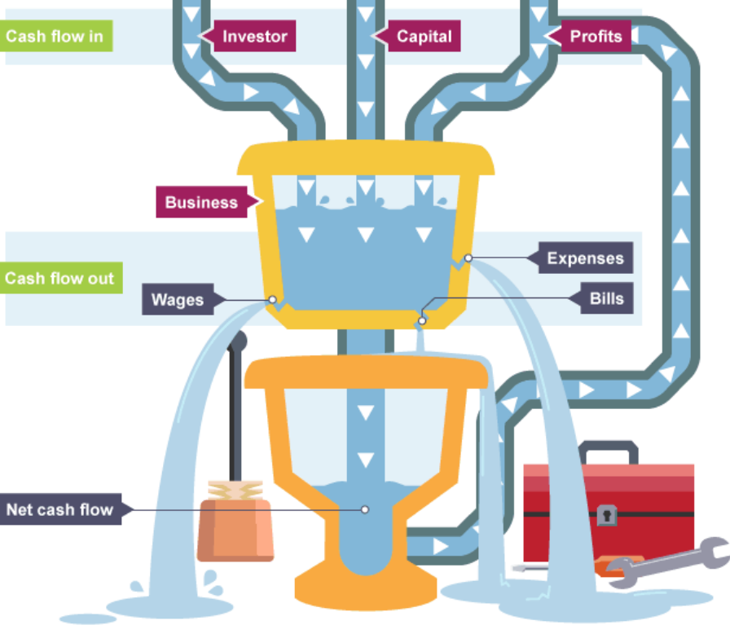

Take a look at the diagram above from BBC Bitesize ©.

It shows all of the cash that flows into a business (cash inflows) and all the cash that flows out (cash outflows) and what remains in the middle is the net cash flow, or in other words, the cash left at the end of each month.

Cash is important because it provides liquidity. Liquidity is the ability of a business to turn assets (thing it owns) into cash. So a shop with stock will have to sell that to get cash. That cash is then used to buy more stock to sell and pay other expenses (costs of running the business).

But what happens if the stock is slow to sell or if you have a seasonal business? In these cases, you’re likely be short of cash in certain months. Over a year, you could have a very profitable business, but in some months there wouldn’t be enough cash to run the business.

CONCLUSION
So it’s important that a business had a good liquidity position.

Cash vs. Profit

There is a clear difference here and examiners want to see you understand that. They’re very picky about getting these mixed up as cash and profit are not the same.

Cash
This is the money held in bank accounts and in cash on the premises that is used to pay short term debts and pay expenses. The amount of cash a business expects to have at a given time is shown in a cash flow forecast.

Profit
Profit is calculated by subtracting total costs from total revenues. A business could have a lot of cash but make little profit. It may also be short of cash for a particular month but be profitable over a year.

Cash flow forecasting

The purpose of a cash flow forecast is to predict when potential cash shortfalls will occur in order to get a source of finance to cover it.

The process starts by identifying a business’ cash inflows and cash outflows, the main examples are shown below.

Cash Inflows  Money flowing into a business. | Cash Outflows  Money flowing out of a business.
Sales Revenue | Wages and Salaries
Loan | Rent
Investment from owners new partners, shareholders, crowdfunding. | Paying suppliers/getting stock/getting materials
Retained Profits | Paying heating and Lighting bills (aka. Overheads)
Sale of assets | Loan repayments and interest
Rent received | Paying for transport

It’s then possible to build a cash flow forecast. An example is shown below.
 | January | February | March
 | £ | £ | £
Cash inflow:
Revenue | 20 000 | 22 000 | 21 800
Total inflow | 20 000 | 22000 | 21 800
Cash outflow:
Sweets | 8200 | 9240 | 6900
Wages | 4200 | 4200 | 4200
Overheads | 8500 | 8500 | 8500
Total outflow | 20 900 | 21 940 | 19 600
Net cash flow | (900) | 60 | 2200
Opening balance | 2000 | 1100 | 1160
Closing balance | 1100 | 1160 | 3360

Cash inflows
This is the money flowing into the business. For January, this is £20,00

Cash Outflows
This is the total the money flowing out the business, For January, this is £20,900.

The Net Cash Flow = Total Inflows- Total Outflows
For January, this is £20,000-£20,900 = -£900

Finally to calculate the closing balance, start with the opening balance, £2000, add the net cash flow if it’s a positive figure or subtract it if it’s negative figure (-£900) and you have the closing balance. £1100. This is then carried forward, so the closing balance of £1100 for January becomes the opening balance for February.
 | January | February | March
 | £ | £ | £
Cash inflow:
Revenue | 15 000 | 22 000 | 21 800
Total inflow | 15000 | 22000
Cash outflow:
Sweets | 6400 | 5240 | 7900
Wages | 5400 | 5200 | 5200
Overheads | 7500 | 6500 | 4500
Total outflow | 19300
Net cash flow | (4300)
Opening balance | 1200
Closing balance |  |  | 6160
Have a go at filling the spaces on this example.

Usefulness and Limitations of Cash Flow Forecasting

Advantages
A planning tool – By using cash flow forecasts, businesses can plan for the future and predict problems. They can then put plans in place to prevent these problems.
Anticipates cash shortages -Cash Flow forecasts predict the flows of cash in and out of the business. These when help businesses to understand when a business may be short of money, to it can plan to have a source of finance in place to cover all of its’ costs
Provides Targets – Gives very clear targets that a business can use to monitor its performance. It is or is not performing well?
Disadvantages
The main disadvantage is that it’s only a prediction based on past data or gut feelings, so it may be inaccurate if these predictions are inaccurate. Therefore, it won’t be useful if the predictions are completely inaccurate.
There’s also a risk that the predictions will be inaccurate due to the biased views of the person creating the cash flow forecast. They may be over-generous with their predictions leaving the whole cash flow forecast inaccurate.

Unit 6 Influences on Business

6.1 Ethical and Environmental considerations

Ethical considerations
Morals:
Standards of behaviour; principles of right and wrong.
Ethics:
Moral principles that govern a person's behaviour or the conducting of an activity.

How can a business act ethically?

The Treatment of Workers

- Not employ child labour
- Pay workers a fair wage
- Ensure workers don’t work long hours
- Provide safe working conditions
- Not discriminate against workers

The Treatment of Suppliers

- Pay suppliers on time, so suppliers don’t face cash flow problems.

Fairtrade
One way a business can act ethically is by guaranteeing to use Fairtrade suppliers wherever it can.

The Fairtrade mark guarantees to a consumer that the retailer has paid a fair price to farmers who produce the goods so that they have extra money to pay for their children’s education or meet other social needs.

However, It can be criticised for:

- Not increasing the earnings of the farmers it sets out to protect by a large enough amount to have any real impact.
- Making countries reliant on Fairtrade sales, so the businesses in these countries don’t work harder to become more efficient or competitive by themselves.

The Treatment of Customers and marketing decisions

- Be careful not to overcharge customers
- Treat customers with respect – be polite, courteous and helpful.
- Avoid making any false claims in adverts.
- Avoid putting customers in danger by selling dangerous products or providing unsafe services.

Sourcing of Materials

- Avoid buying from businesses that use child labour or pay beneath the minimum wage.
- Avoid buying from businesses that act in a way that harms the natural environment.

Impact of Ethical Considerations on Businesses

Possible advantages | Possible disadvantages
If workers are paid a fair wage and work in good conditions, there should be improved employee happiness. Happier employees will work harder, produce more and reduce costs. | There may be higher costs involved as business must pay higher wages and offer better working conditions. This could reduce overall profits.
Business will have an Increased reputation thanks for acting ethically. This should lead to higher sales to customers, revenues and profits. | Sales may fall if a business makes honest claims about its products, convincing less people to purchase its products.
Higher sales and better reputation should increase the number of possible investors and shareholders, giving the business more money to use to improve. | Investment from shareholders may be lower if profits have fallen due to any increased costs, giving the business less money to use in order to improve its business.
Improved ethical profile and feelings of self-achievement/positive impact on the human race.

Environmental considerations

Sustainable Production
Sustainable production is making and providing goods and services without depleting natural resources in a way that will leave less resources available for future generations.
In practice, the use of renewable resources and recycled resources increases how sustainable a business is.

The Sustainability Problem
The sustainability problem refers to the current problem faced by 21st century citizens that high amounts of business behaviour is fuelled/supported by unsustainable methods, including:
- Burning fossil fuels to heat and power buildings and vehicles.
- Construction methods that use non-renewable resources.
- High chemical use within soils when growing crops.
- Using a large amount of water and paper in the production of goods/services
- Generating and irresponsibly disposing of a large amount of waste.

Pollution and Business
What is Pollution?
Pollution is defined as a business causing harm to the environment.

How do businesses cause Land Pollution?

Businesses cause land pollution by sending lots of waste (and unnecessary waste) to landfill sites. They can reduce this by using less materials or using recyclable materials.

How do businesses cause Air Pollution?

Business cause Air Pollution by emitting smoke and other gases into the environment from their factories and vehicles.. This can cause smog that is harmful to humans and can lead to global warming. This can be reduced if businesses switch to renewable energies, such as solar and wind power and reduce the number of vehicles it places on roads.

How do businesses cause Noise Pollution?

Loud factories and vehicles on the roads create noise for stakeholders living near the factories and the roads. Businesses can reduce this by soundproofing factories and recuing the number of vehicles on the roads.

How do businesses pollute the seas and the rivers?

Businesses have been known place lots of their waste into rivers, or more simply, use large ships that empty their waste and exhaust fumes into the seas. They can reduce this by using less materials or using recyclable materials or reducing their usage of ships.

Methods of acting sustainably
- Use renewable energy  - Use recycled materials.  - Recycle all waste.  - Use electric vehicles.  - Turn lights off. | - Only use materials from nearby suppliers to reduce vehicles needed to move the

Advantages and Disadvantages of acting in an Environmentally Friendly Manner.

Advantages | Disadvantages
Costs may be lower because a business may have taken steps to use less energy or create les waste, reducing energy bulls and waste disposal costs. | Production costs may be higher if materials produced in an environmentally friendly waste are more expensive.
Sales may be higher because customers may prefer to buy from a business that care about the environment. | Sales may be lower if the business charges higher prices to cover any extra costs of environmentally friendly production
Lower taxes and avoidance of paying fines may occur because a business creates less pollution. | Capital costs may rise if the business invests in new machines and plant to produce in an environmentally friendly way.
A business may gain subsidies from the government to help pay for environmentally-friendly production.

6.2 The Economic Climate

Income and Employment Levels

The economic climate is made up of two main elements:

- Consumer Income levels: The level of income received by people in a country is important for businesses because it influences how much money people have to spend on goods and services.

- Employment and unemployment levels: Employment and unemployment levels influence income. A person in work will earn a wage or salary and will often have more income than a person who is unemployed, who may only receive welfare beneftis.

A fall in GDP, or weakening of the economic climate, means that businesses are making fewer sales.

As a result, businesses may cease to trade or may have to either:
Employ fewer new staff
Postpone wage rises
Reduce wages (unlikely)
Make workers redundant

The overall impact of this is to reduce employment (increase unemployment) and reduce people’s incomes.

This lowered income further adds to the problem as citizens in the economy now have less to spend, so a business’ sales fall even further.

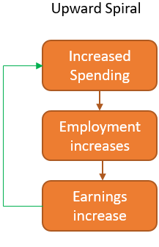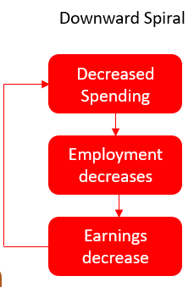

Impact on Businesses

Rising Income/Employment | Lowered Income/Employment
Sales should rise as people have more money. | Sales will probably fall as people have less money.
Businesses will want to increase sales further to take advantage of the higher demand.  Therefore they’ll employ more workers, buy more stock from suppliers, build/extend new factories or add new shops. | Businesses will need to reduce costs.  Therefore they may postpone wages rises, make workers redundant, reduce the amount of stock they buy from suppliers and close factories/shops.
There will be fewer employees to choose from when hiring for a job, so businesses may need to offer higher wages and may struggle to keep its best staff who are persuaded to go elsewhere. | There should be more employees to choose from, so businesses don’t have to offer such high wages to persuade them to come join their business. They may also find it easier to keep their best staff.
What does this depend upon?
This size of the income or employment change – if incomes only change a little bit, there’s unlikely to be much of a reaction from businesses.
Who the income change hits most – Will the incomes fall for the richest in society, who can handle the hit, or the poorest, who will have to spend less.
The type of product the business sells – Necessary goods are unlikely to be affected, but luxury goods are likely to see falling/rising sales.
How competitors respond – If a competitor begins to take advantage, such as Aldi, it’s competitors may need to respond.
The type of people a business employs – If a business employs skilled workers but there is now a shortage of these, the business will struggle, but lower-skilled workers may still be readily available.

Responding to changes

Changing Production methods and Levels | - Switch to machinery that is cheaper to run and creates lower wastage.  - Move production to cheaper part of the world.  - Train employees to be more productive, producing more output for the same cost.
Changing Human Resource Plans | - Motivate workers using monetary and non-monetary motivation methods to improve their productivity.  - Pay workers less or delay their pay rises.  - Hire fewer/no new workers.  - Make current workers redundant.
Changing Finance Plans | - Improve cash flow by delaying/reducing outflows.  - Increase inflows by getting a new source of finance.  - Switch loans to a new provider with a lower
Changing Marketing Plans | - A change to a newer, cheaper to make product might need a new marketing campaign to introduce/explain the change.  - Run a marketing campaign to make people want the product that’s fallen in sales again and combat that fall in demand.  - Perform market research to find out what customers want now they have a lower income.  - Change pricing strategies to persuade people to buy products.  - Change the location of its outlets (place) to reach new customers.

6.3 Globalisation

What is Globalisation?

Globalisation refers to how businesses in different countries have become increasingly connected in their activities.

It involves:
Buying and selling goods and services made in different countries.
The movement of workers from country to country.
The movement of capital or finance from country to country.

What has caused globalisation?

Transport | Transport costs have reduced as ships and planes have become bigger and rail and road networks have improved.  Shipping containers have become larger and goods can be more easily delivered in inexpensive packaging.
Telecommunications and the Internet | Communication has become faster and easier and the internet has enabled businesses to communicate with other businesses and potential customers across the globe.
Free trade agreements | Free trade exists when there are no barriers to trade between different counties. These would be tarrifs (taxes on imports or exports) or quotas on how many imports can be brought in or exports sent out.  Many countries now have free trade agreements with each other.  We’re trying hard to make an agreement with the EU.

Impact of Globalisation

The growth of Multinational Companies.
A multi-national company is a company that operates in more than one country

Advantages of being an Multi-National Company

Advantages | Disadvantages
Increasing sales in bigger markets can mean higher revenues and then profits for businesses. | Greater competition from businesses who move into a business’ original market, potentially lowering sales.
The risk of failing is spread and reduced as businesses have a higher demand from lots of different countries. | Higher costs for the business of transporting goods globally/
Lower Costs with cheaper labour/ technology in different countries for businesses. | More complex to manage the business across a global market, leading to decisions made in one part of the world impacting the reputation of the business elsewhere.
Tax Avoidance by locating in lower tax countries, reducing costs.
Access to more workers in foreign countries, improving productivity.

Advantages and Disadvantages to hosting an MNC’s

For example:
India and/or Vietnam allowing McDonalds to open or Nike open factories

Advantages | Disadvantages
Greater demand for host country businesses. When businesses move to less developed countries, they will employ local workers who spend their money at local businesses. | Business closures  Local businesses may be unable to compete with the larger MNC and may have to close, making workers redundant.
Taxes and Public Services Local governments can tax the newly located MNC and use the tax to help improve education and health services. | Outflows of money  The profits made by MNCs in other countries may be moved back to original countries to pay dividends to shareholders and wages of employees, seeing money leaving the new host country.
Lower prices The MNC might bring better ideas and new competition for native businesses, reducing costs for customers.

The influence on business location

Advantages and Disadvantages of locating abroad
Advantages | Disadvantages
Lower costs (labour)  For many years UK businesses have been moving production to the Far East as wages are lower in these countries, meaning a business can produce more for less. | Quality Control Problems and lower access to skilled labour.  Businesses may find that unskilled workers in new countries produce a lower quality product and are harder to train if they have a lower education level.
Lower costs (technology)  Some countries, such as South Korea and parts of the USA (California) have much better technology than the UK for a lower cost, meaning a business can produce more for less. | Communication difficulties  When operating across the globe, there may be problems of people speaking different languages or not being able to use the best communication methods, such as no access to fast interest. This may lead to decision slowing down.
Lower costs (properties and land)  Land is generally cheaper in less developed and poorer nations, which means businesses can build factories here. | Transport costs  Operating globally may lead to a high transport cost for businesses trying to move goods and materials across the world.
Expertise, Skills and Knowledge.  The UK is well known for having a highly skilled economy that’s good for research, development and science. A business may locate here to take advantage of that. | Loss of sales  Newly redundant workers in the UK who lost jobs when businesses moved abroad will have lower incomes and may buy less from the business, reputation may also fall as a business is no longer “British”.
Higher Demand  Some markets will have very high demand for certain products or a so-far untapped demand, such as the electric car company that found demand was higher for its electric cars in Denmark. | The Environment  A business’ overall pollution may increase due to higher transport and increased global operations that harms the planet and reduces a business’ reputation.

The development of international brands

What is Branding?

Branding is about creating an image for a business what will influence the way that people view that business using logos, music, words and images.
Businesses spend lots of money on their “brand image” to try and create a positive brand image, that makes people want to engage with the business and buy their products.
This often means advertising core principles rather than products. Consider the following:

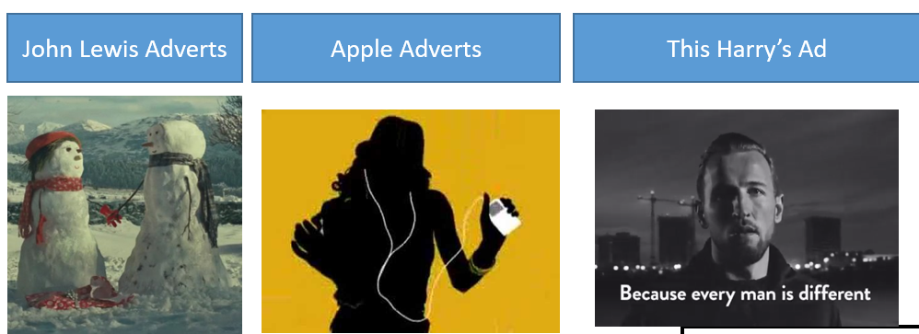

What is International Branding?

International Branding is about creating a name for a business what will influence sales across more than one country.
This is important to any Multi-National Company that needs to sell its products across the world.
The brand image should be very similar regardless of country, but be adapted slightly to accommodate the different views and cultural factors of different counties.
This is instead of having a different message and different brand in each country that you operate in, which can cause confusion, be time-consuming and costly.

What to consider when building an International Brand

Consideration | Description
Language | Any brand image must be easily translated into different languages, but still retain the same message surrounding the quality, product and principles.
Product Names | Product names needs to be understandable in different countries. They may also need to be changed, for example Burger King is called Hungry Jac’s in Australia as Burger King already existed and the Chinese Burger King “PooPoo” milkshake may not sell well in the UK.
Distribution of income | A business needs to think about whether its product will be affordable in the country it’s building its brand in. There would be little point advertising expensive products in low income areas.
Local laws | Businesses will need to obey the laws in the countries in which they operate. There may be laws about advertising, such as laws around advertising cigarettes in certain countries.

Benefits and Drawbacks of International Branding

Advantages | Disadvantages
Higher trust and higher sales  Sales are likely to be higher due to a higher collective demand across all areas as people tend to trust a large MNC more. | Risk of offence  Some adverts that are used in some countries may offend those in other countries, lowering sales and reputation.
Reduced Risk  A business that operates across several areas has a lower risk of failing as sales are likely to be higher. | Higher Costs  Employing marketing managers to manager lots of adverts can be very expensive.
Reduced Costs  Costs of advertising will be lower as some adverts can be used in all areas. | Higher competition  Moving into foreign areas may lead to competitors fighting back by entering into a business’ original market/country, reducing that business’ overall sales.
Can use International Social Media
Social Media can be used for a very low/no cost to run a campaign that stretches across multiple countries

Appendix A: Long Mark Questions, structures and Mark Schemes

Dixons Carphone starts as two separate stores. Dixons opened in 1937, selling electrical goods, and Carphone Warehouse started in 1989, selling mobile phones. Dixons merged with Currys and PC World and then merged with Carphone Warehouse in 2014 to create Dixons Carphone.
In all this time, there was great competition from other businesses. The growth of online sales at competitor business has put further pressure on Dixons Carphone with customers often looking in store before buying online.
Dixons Carphone sell a range of electrical goods, such as Mobile phone, TVs, Stereos and Laptops.
- Recommend a Pricing Strategy that Dixons Carphone could use to ensure that sales are kept at a high level [9].
Structure:
The trigger word is recommend, so you must finish by making a recommendation.
- Introduction to the essay :
“In this essay I am going to...”
- Define the first possible pricing strategy.

“The first pricing strategy that they could use is ____, this is where...”

- A benefit of this strategy and how it will help Dixons Carphone (refer to their competition or type of products).

“A benefit of this strategy is... This will impact the business because...”

- A drawback of this strategy and how it will harm Dixons Carphone (refer to their competition or type of products)
“However, this could be limited by the drawback of... This will impact the business because...”
- Define the second possible pricing strategy.

- A benefit of this strategy and how it will help Dixons Carphone (refer to their competition or type of products).

- A drawback of this strategy and how it will harm Dixons Carphone (refer to their competition or type of products).

- Conclude by weighing up the pros and cons of both and making a recommendation

“Overall, I recommend that Dixons Carphone uses the ________________ pricing strategy. I think this because the advantages such as.... outweigh the disadvantages of...

Mark Scheme
Summary: Overall, the answer should weigh up 2 potential pricing strategies, their benefits, drawbacks and then recommend which should be used. The student may choose to look only at one strategy, but they will have gone into depth in the drawbacks to evaluate how it’s overall effectiveness may be limited.
Finding the marks per point
A01 – Knowledge = 2 marks
- 1 mark for showing knowledge of pricing strategies and their benefits/drawbacks (see revision guide).
- Up to a maximum of 2 marks.
A02 – Application = 2 Marks
• 1 mark for applying knowledge directly to the case study.
• Up to a maximum of 2 marks.
A03a – Analysis = 2 Marks
• 1 mark for analysing the impact of knowledge points in relation to the case study business.
• Up to a maximum of 2 marks.
A03b - Evaluation = 3 Marks
• 1 mark for evaluating the impact of knowledge on the business in the case study, relating back to the question and making some form of judgement. This could be in the conclusion or in the form of a limiting factor (however point).
• Up to a maximum of 3 marks.
Grading the answer based on it’s levels
Level 3 7-9 Marks
A top level answer will show good knowledge (AO1), with good application to the case study (AO2) and good analysis of it’s impact in relation to the business in the case study (eg. The impact has something to do with the business, is related to what it makes, or the industry it is in!). It will have good evaluation that summaries the points.
Level 2 4-6 Marks
A medium level answer will show good knowledge (AO1), with good application to the case study (AO2), but will have limited analysis and evaluation. There may be some evident, but little to award more than 1 mark for each.
Level 1 1-3 marks
A low level answer will show limited knowledge (AO1), with limited application to the case study (AO2). There will be a very limited analysis of the impact (1 mark max) and no evaluation/weighing up of points.

AV Dresses Ltd. is a private limited company owned by Amy Valance and Helen Shoreham. The business manufactures dresses for formal occasions. The business has been running for 18 months and has a small amount of cash now held in reserves after a reasonable amount of success.
AV Dresses Ltd. Has been operating from a garage at Amy’s house. They currently manufacture the dresses together using their combined skills developed during their history in the fashion industry. They currently sell their dresses in a local shop and online via stores such as Amazon and Ebay.
Amy and Helen would like to expand the business. Amy feels that a business plan should be drawn up to help maximise any chance of success, but Helen is unconvinced of the idea. She feels like their time could be better spend on developing a website and producing the plan.
- Evaluate the usefulness to Amy and Helen of creating a Business Plan [9]

- Introduction to the essay :
“In this essay I am going to...”
- Define the first benefit of using a Business Plan.

“A business plan can help a business succeed...”

- How will this will help Amy and Helen succeed (refer to their competition or type of products).

“This will impact the business because...”

- Define the first drawback of using a Business Plan.

“However, this is limited by...”

- How will this will harm Amy and Helen chances of succes (refer to their competition or type of products).

“This will impact the business because...”

- Define the second benefit..

- How will this will help Amy and Helen succeed (refer to their competition or type of products).

How will this will harm Amy and Helen chances of success (refer to their competition or type of products).

- Conclude by weighing up the pros and cons of both and making a decision

“Overall, business plans do/don’t help...”

Mark Scheme
Summary: Overall, the answer should weigh up 2 benefits of using a business plan and discuss how they are limited by the drawbacks of the time needed to complete one and the money used to pay for the staff to complete it. The conclusion is likely to draw that the benefits outweigh the negatives. (See revision guide for content)
Finding the marks per point
A01 – Knowledge = 2 marks
- 1 mark for showing knowledge of pricing strategies and their benefits/drawbacks (see revision guide).
- Up to a maximum of 2 marks.
A02 – Application = 2 Marks
• 1 mark for applying knowledge directly to the case study.
• Up to a maximum of 2 marks.
A03a – Analysis = 2 Marks
• 1 mark for analysing the impact of knowledge points in relation to the case study business.
• Up to a maximum of 2 marks.
A03b - Evaluation = 3 Marks
• 1 mark for evaluating the impact of knowledge on the business in the case study, relating back to the question and making some form of judgement. This could be in the conclusion or in the form of a limiting factor (however point).
• Up to a maximum of 3 marks.
Grading the answer based on it’s levels
Level 3 7-9 Marks
A top level answer will show good knowledge (AO1), with good application to the case study (AO2) and good analysis of it’s impact in relation to the business in the case study (eg. The impact has something to do with the business, is related to what it makes, or the industry it is in!). It will have good evaluation that summaries the points.
Level 2 4-6 Marks
A medium level answer will show good knowledge (AO1), with good application to the case study (AO2), but will have limited analysis and evaluation. There may be some evident, but little to award more than 1 mark for each.
Level 1 1-3 marks
A low level answer will show limited knowledge (AO1), with limited application to the case study (AO2). There will be a very limited analysis of the impact (1 mark max) and no evaluation/weighing up of points.

The Petite Food Company produces and provides food for a range of businesses across Lancashire. Typical clients include large corporations and schools, most of which provide canteen-style services to their workforces.
The Petite Food Company has a clear organisational chart with roles delegated throughout the business, this is shown below.

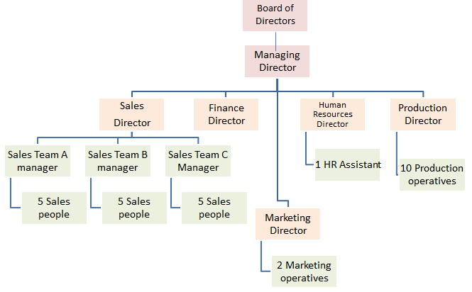
Over the past 18 months, sales across all product lines have seen an average 20% increase with increases in the sales of foods for special dietary requirements, such as gluten and lactose free, seeing a 55% rise.
Product type | Sales increases
Traditional hot food ingredients | 15%
Traditional pre-prepared lunches | 25%
Foods for special dietary requirements | 55%
Drinks | 20%
Other products | 20%

QUESTION ON NEXT PAGE
- Evaluate the impact that the choice of a tall structure may have on the success of the Petite Food company [9]

- Introduction to the essay :
“In this essay I am going to...”
- Define the first benefit of using a tall structure.

“A tall structure can help a business succeed...”

- How will this will The Petite Food Company (refer to their competition or type of products).

“This will impact the business because...”

- Define the first drawback of using a structure or the missing benefit of using a flat.

“However, this is limited by...”

- How will this will The Petite Food Company’s chances of succes (refer to their competition or type of products).

“This will impact the business because...”
- Define the second benefit of using a tall structure.

- How will this will The Petite Food Company (refer to their competition or type of products).

- Define the second drawback of using a structure or the missing benefit of using a flat.

- How will this will The Petite Food Company’s chances of succes (refer to their competition or type of products).
- Conclude by weighing up the pros and cons of both and making a decision

“Overall the tall structure has helped the business by... But this will have been limited by..”

Mark Scheme
Summary: Overall, the answer should weigh up 2 benefits of using a tall structure and discuss how they are limited by their drawbacks or by missing out on the benefits of using a flat structure. The conclusion is likely to draw that the tall structure is appropriate in this case as it is a large business.
A01 – Knowledge = 2 marks
- 1 mark for showing knowledge of pricing strategies and their benefits/drawbacks (see revision guide).
- Up to a maximum of 2 marks.
A02 – Application = 2 Marks
• 1 mark for applying knowledge directly to the case study.
• Up to a maximum of 2 marks.
A03a – Analysis = 2 Marks
• 1 mark for analysing the impact of knowledge points in relation to the case study business.
• Up to a maximum of 2 marks.
A03b - Evaluation = 3 Marks
• 1 mark for evaluating the impact of knowledge on the business in the case study, relating back to the question and making some form of judgement. This could be in the conclusion or in the form of a limiting factor (however point).
• Up to a maximum of 3 marks.
Grading the answer based on it’s levels
Level 3 7-9 Marks
A top level answer will show good knowledge (AO1), with good application to the case study (AO2) and good analysis of it’s impact in relation to the business in the case study (eg. The impact has something to do with the business, is related to what it makes, or the industry it is in!). It will have good evaluation that summaries the points.
Level 2 4-6 Marks
A medium level answer will show good knowledge (AO1), with good application to the case study (AO2), but will have limited analysis and evaluation. There may be some evident, but little to award more than 1 mark for each.
Level 1 1-3 marks
A low level answer will show limited knowledge (AO1), with limited application to the case study (AO2). There will be a very limited analysis of the impact (1 mark max) and no evaluation/weighing up of points.

The Burton Roastery Company is a small yet highly successful Coffee Roastery Company based in Burton. The company produces several lines of Coffee with subtly different flavours and strengths. The business currently sells online to the UK market and in 15 independent shops in the North East of England.
Rosie Denton, the company’s marketing director has produced a comprehensive report of the product lines, their sales and popularity. She has found that one of its most famous lines, the “Classic Intense Aroma” appears to have reached the maturity stage of the product life cycle, shown below.
- Recommend two extension methods that the Burton Roastery could use to grow the sales of the “Classic Intense Aroma” [9]
A 7 marker requires less input from you, see it as having 7 minutes. You don’t need pros and cons, just recommendations and why they’ll work, all applied with one limiting factor.
- Introduction to the essay :
“In this essay I am going to...”
- Define the first potential extension strategy.

“The first extension strategy that the business could use is...”

- How is this linked to the Roastery/how will it help them? Quote the case study.

“This will impact the business because...”

- What will limit this from working?

“However, this is limited by...”

- Define the second potential extension strategy.

“The first extension strategy that the business could use is...”

- How is this linked to the Roastery/how will it help them? Quote the case study.

“This will impact the business because...”

- What will limit this from working?

“However, this is limited by...”

- Conclude by summarising your recommendation and stating why the benefits outweigh the limiting factors.

“Overall the tall structure has helped the business by... But this will have been limited by..”

Mark Scheme
Finding the marks per point.
Summary: Overall, the answer should weigh up 2 potential extension strategies, their benefits, and what may limit them from working. Any strategy is correct, so long as it is linked back to the business - saying how it’ll work in context.
A01 – Knowledge = 2 marks
- 1 mark for showing knowledge of pricing strategies and their benefits/drawbacks (see revision guide).
- Up to a maximum of 2 marks.
A02 – Application = 2 Marks
• 1 mark for applying knowledge directly to the case study.
• Up to a maximum of 2 marks.
A03a – Analysis = 2 Marks
• 1 mark for analysing the impact of knowledge points in relation to the case study business.
• Up to a maximum of 2 marks.
A03b - Evaluation = 3 Marks
• 1 mark for evaluating the impact of knowledge on the business in the case study, relating back to the question and making some form of judgement. This could be in the conclusion or in the form of a limiting factor (however point).
• Up to a maximum of 3 marks.
Grading the answer based on it’s levels
Level 3 7-9 Marks
A top level answer will show good knowledge (AO1), with good application to the case study (AO2) and good analysis of it’s impact in relation to the business in the case study (eg. The impact has something to do with the business, is related to what it makes, or the industry it is in!). It will have good evaluation that summaries the points.
Level 2 4-6 Marks
A medium level answer will show good knowledge (AO1), with good application to the case study (AO2), but will have limited analysis and evaluation. There may be some evident, but little to award more than 1 mark for each.
Level 1 1-3 marks
A low level answer will show limited knowledge (AO1), with limited application to the case study (AO2). There will be a very limited analysis of the impact (1 mark max) and no evaluation/weighing up of points.

