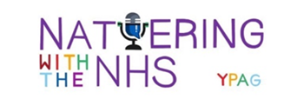
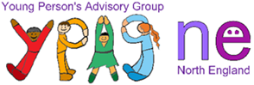

Nattering with the NHS

YPAGne (Young Person’s Advisory Group North England) present young people with the chance to participate in constructive projects and by engaging in these you can gain a set of useful skills valued by universities and employers.

Nattering with the NHS is a new YPAG project. Covid-19 has halted work experience for young people at a time it is needed more than ever. YPAG have come up with the idea of hosting a live podcast giving young people the opportunity to chat to different professionals and ask questions about their roles/jobs and the skills required to do their job.

The aim of these sessions is to help young people work out what field they would like to go into by exploring options. It’s a great way for young people to learn from and communicate with professionals in their interested vocation. These sessions will also be recorded to create a library of episodes for young people to use in the future.
The 1st live episode is Wednesday 26th May at 5.30pm & we would love for you to join us! Follow us on social media to find out who the first guest will be & how to join in
@YPAGne
@YPAGne

@natteringwiththeNHS

Please share with your friends!

